## **Supplementary Information**

### **Section S-1: Correction Equations**

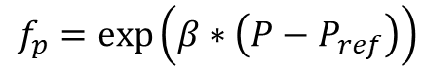

fp = air pressure correction

β = barometric pressure coefficient

P = air pressure (hPa)

Pref = reference air pressure (hPa)

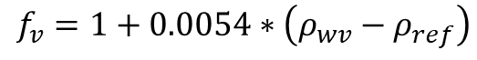

fv = atmospheric water content correction

ρwv = atmospheric water content at 2m height (g/m3)

ρref = reference atmospheric water content at 2m height (g/m3)

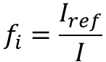

fi = cosmic ray intensity correction

Iref = reference incoming cosmic ray intensity (cps)

I = incoming cosmic ray intensity (cps)

#### **Figure S1: Npvi Time Series**

A)

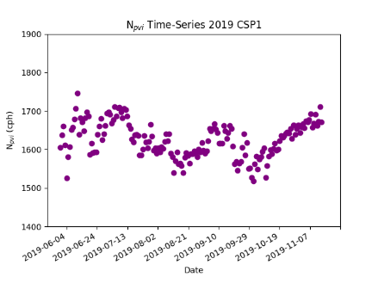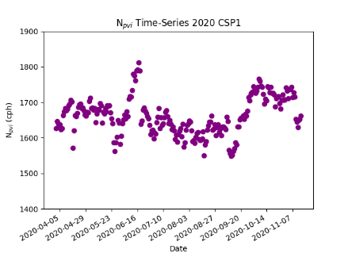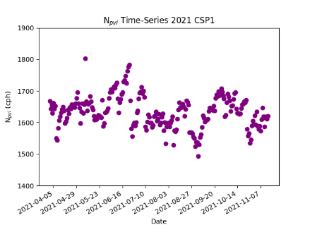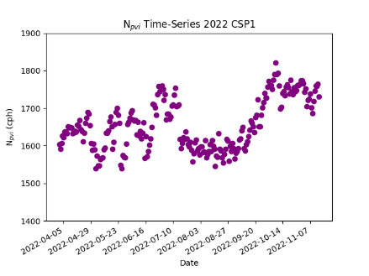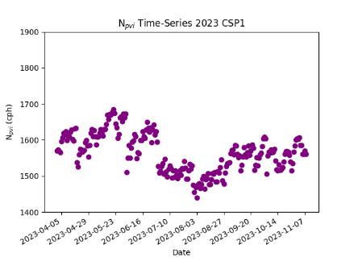

B)

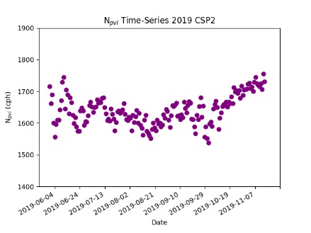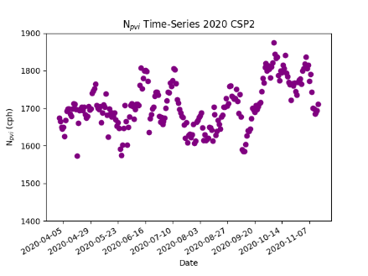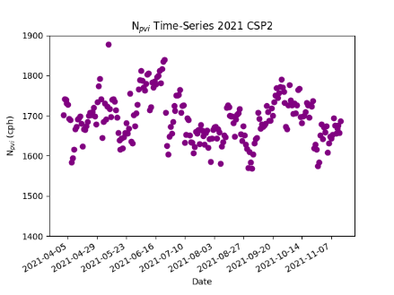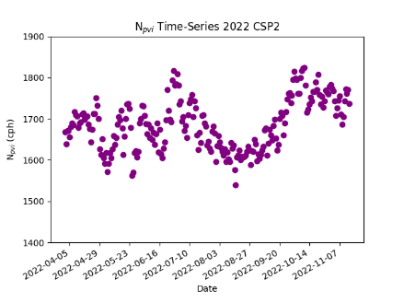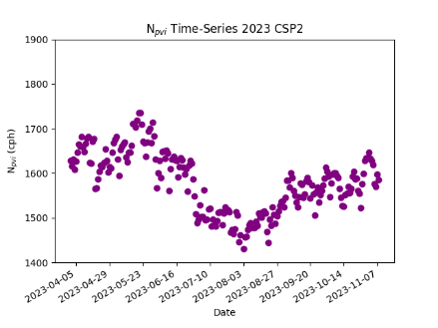

C)

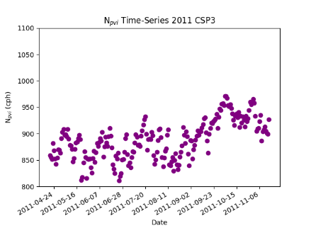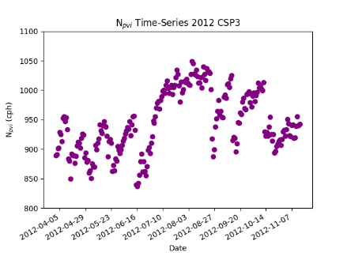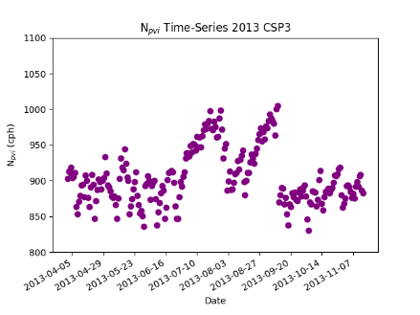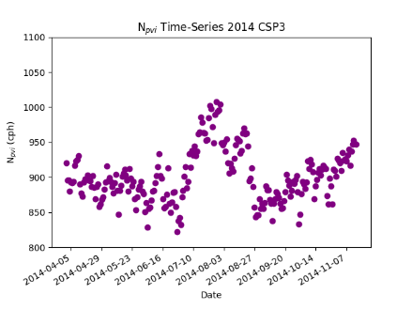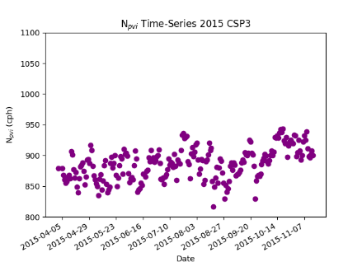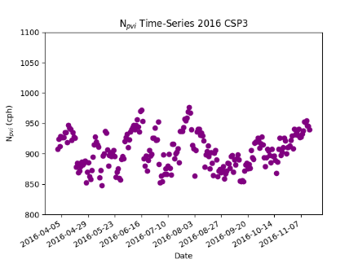

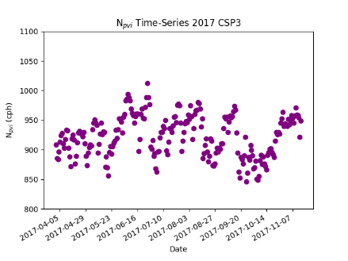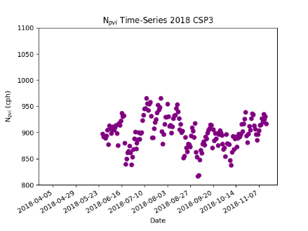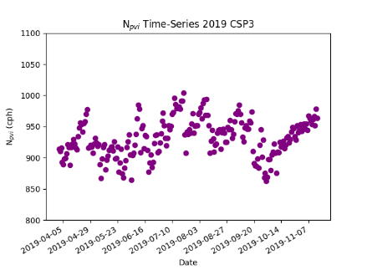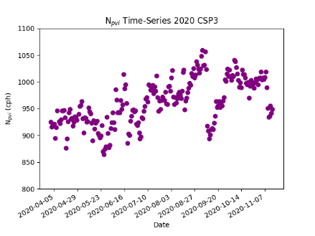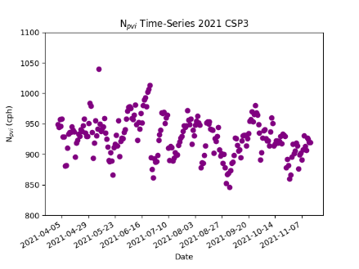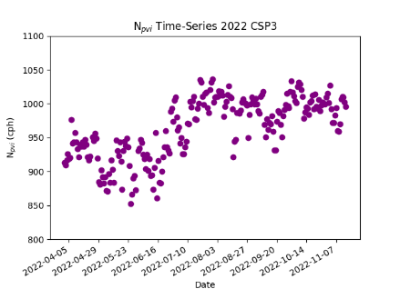

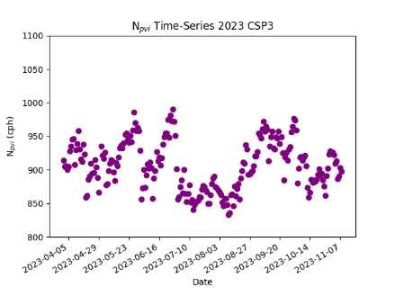

Figures S1: Plots of raw *Npvi*datetime neutron counts. Panels A are all time series for CSP1, Panels B are all time series for CSP2, and Panels C are all time series for CSP3.

#### **Figure S2: N0 Time Series**

A) B) C)

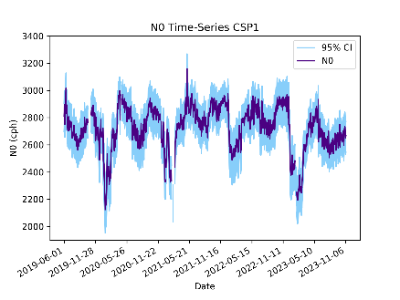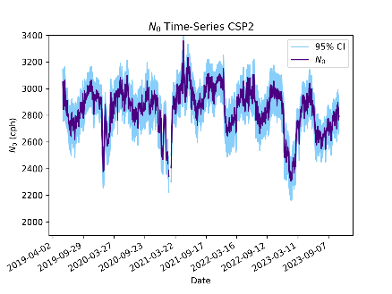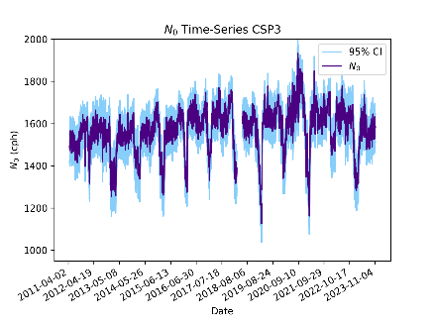

D)

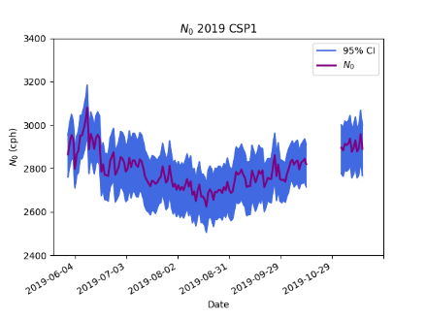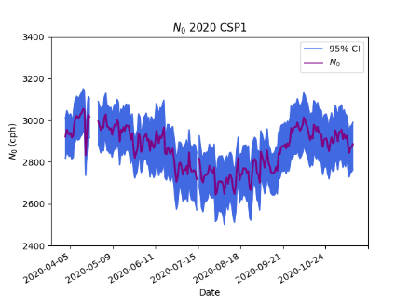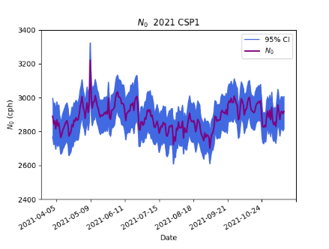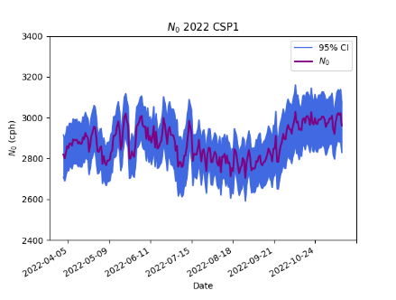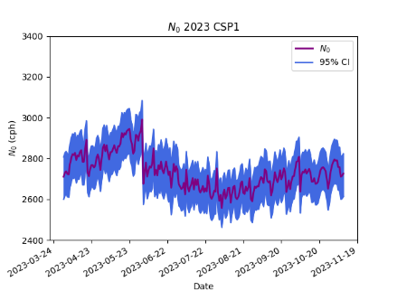

E)

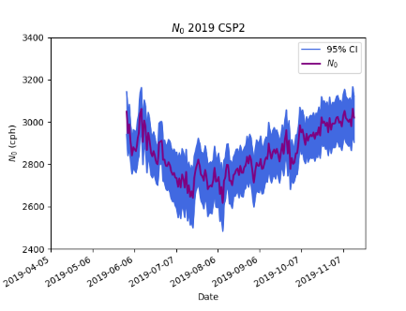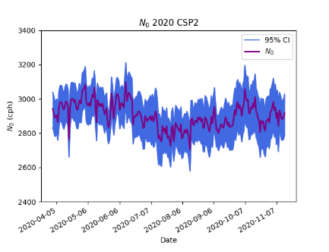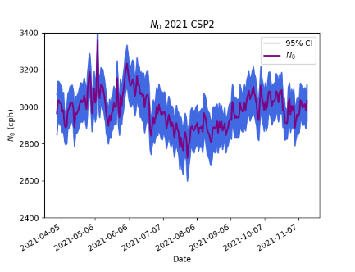

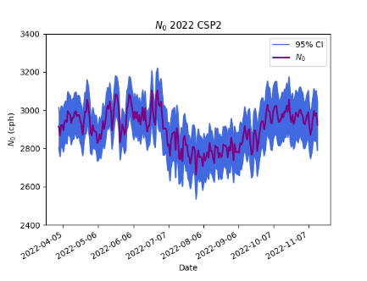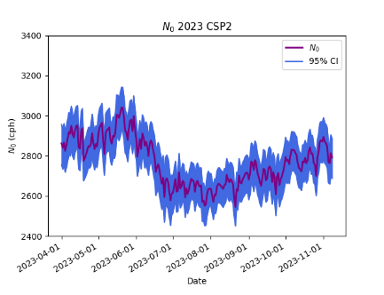

F)

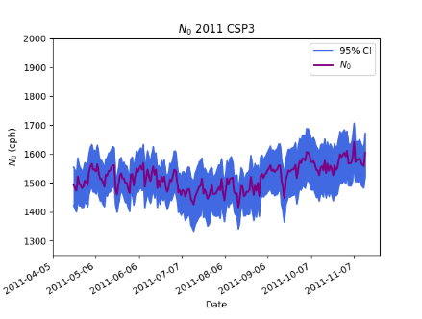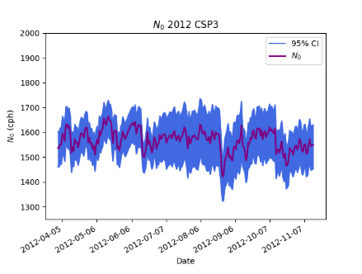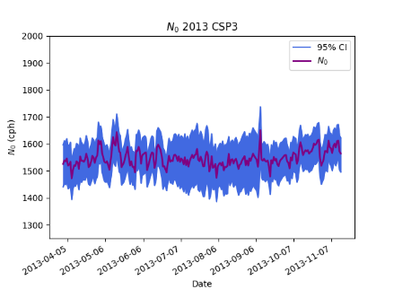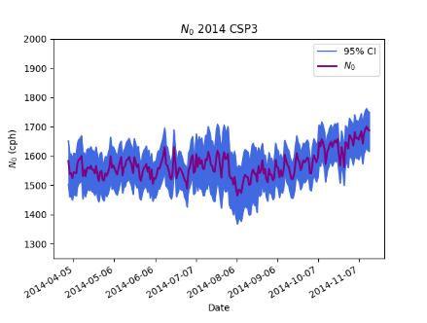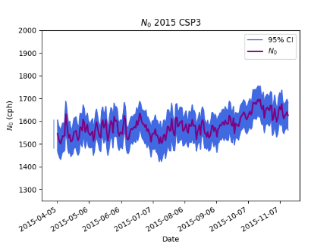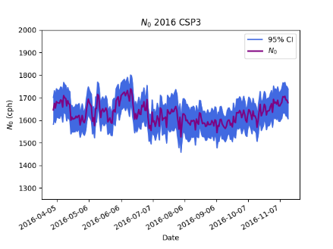

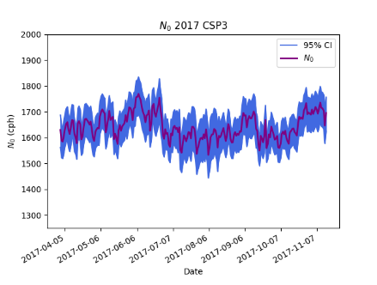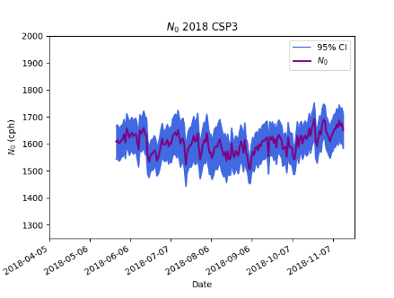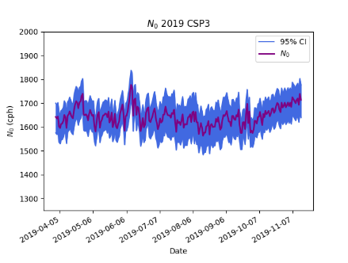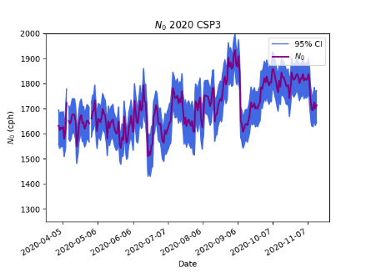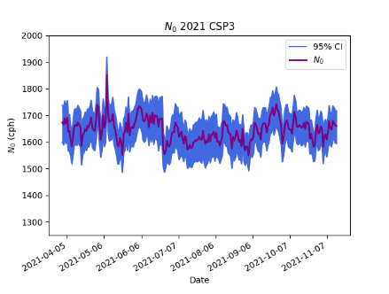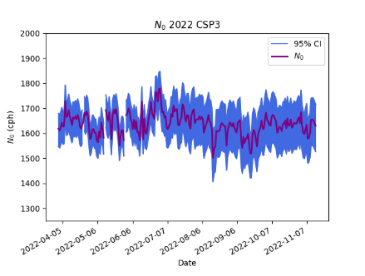

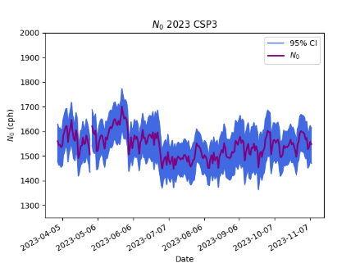

Figures S2: Plots of *N0* datetime neutron counts. Panels A, B, and C are full time series (winter included) for CSP1, CSP2, and CSP3 respectively. Purple represents real measurements, and blue shows the 95% confidence interval. Panels D, E, and F are yearly (April – November) time series for CSP1, CSP2, and CSP3 respectively.

#### **Figure S3: BWE Time Series**

A)

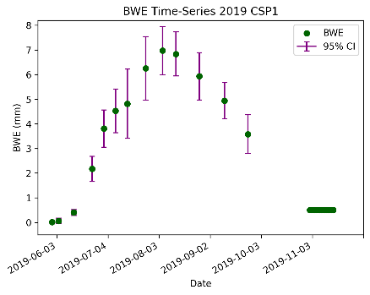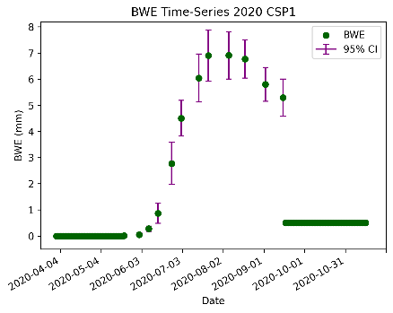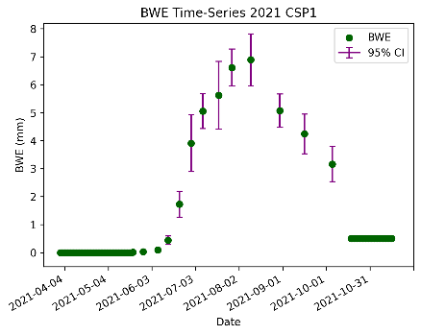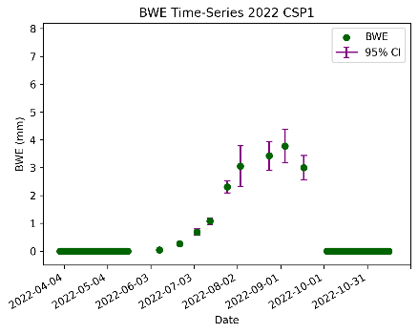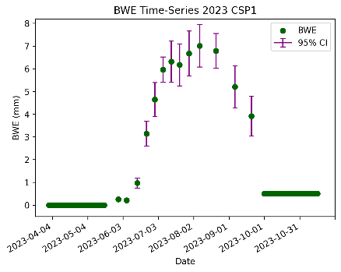

B)

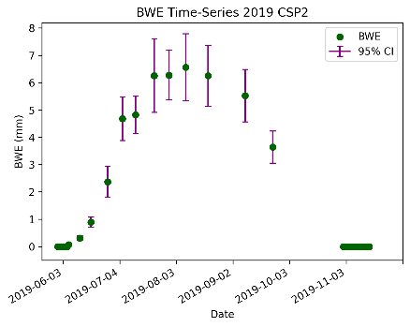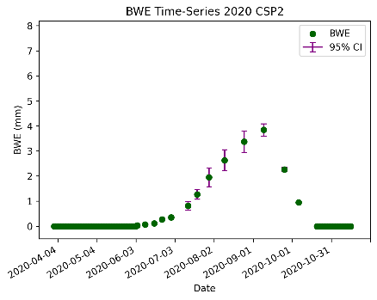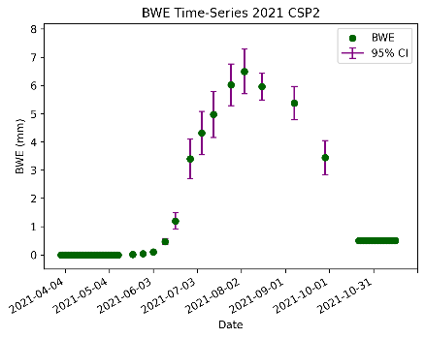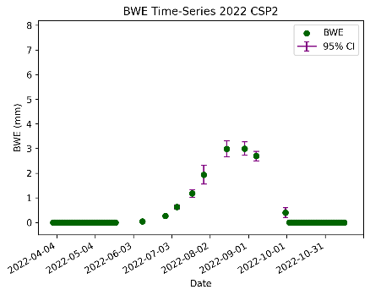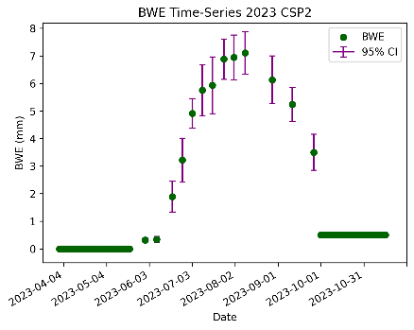

C)

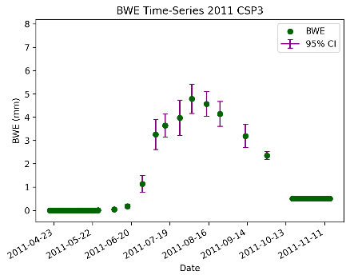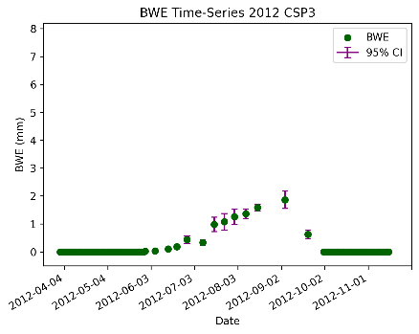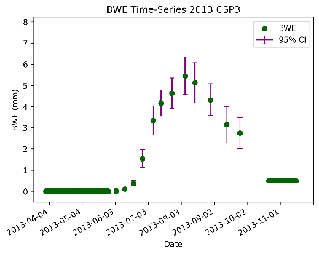

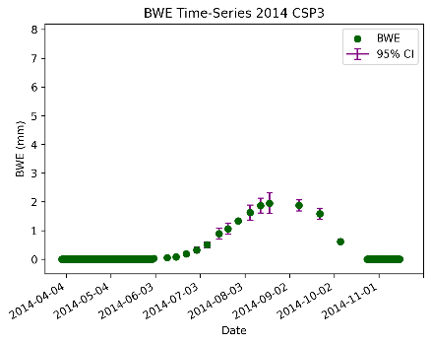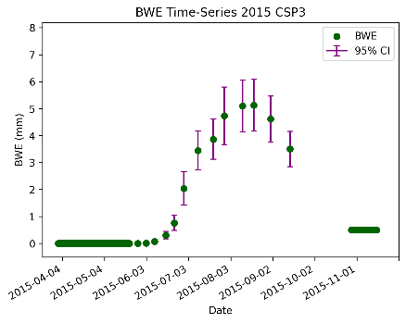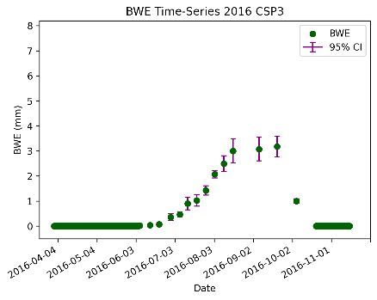

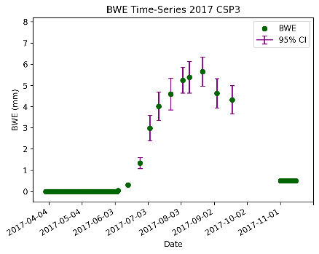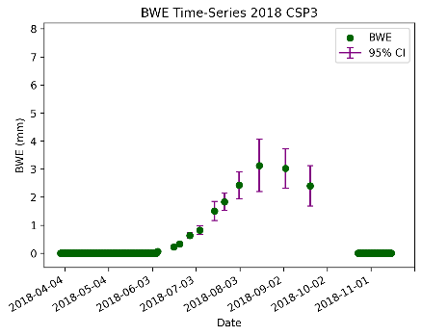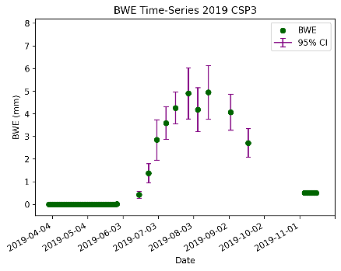

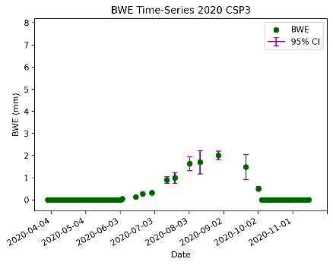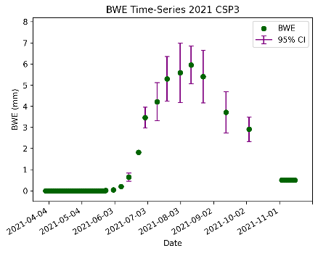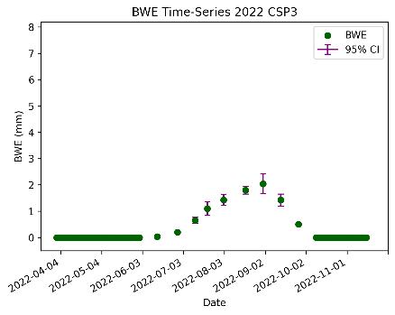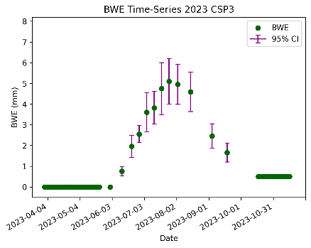

Figures S3: Plots of *BWE* datetime measurements. *BWE* measurements are green, and purple bars represent the 95% confidence interval. Panels A, B, and C are yearly time series for CSP1, CSP2, and CSP3 respectively.

#### **Figure S4: Npvi, N0, and BWE**

A)

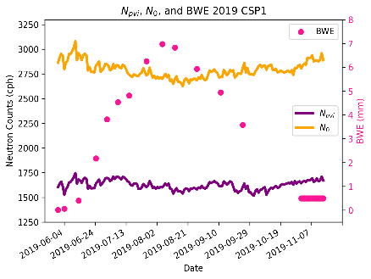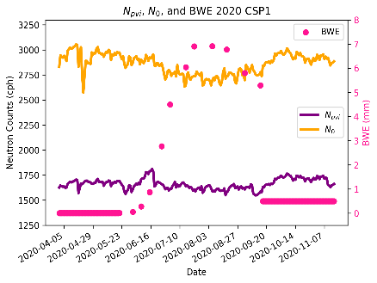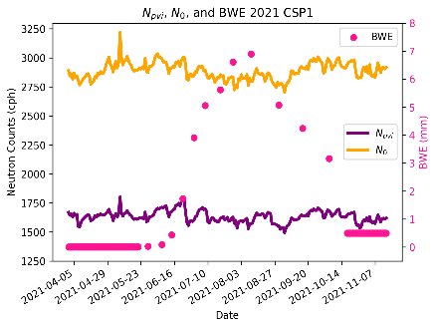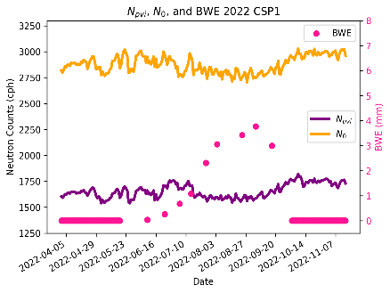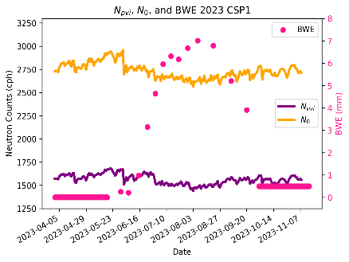

B)

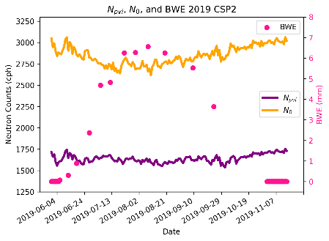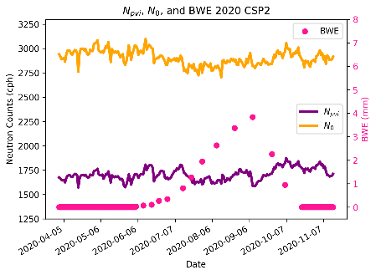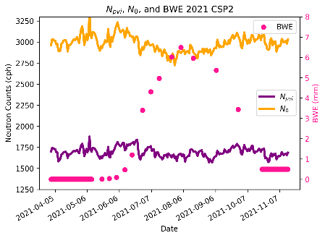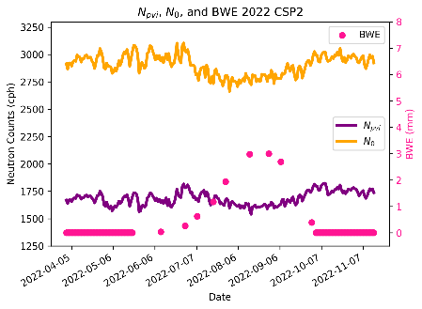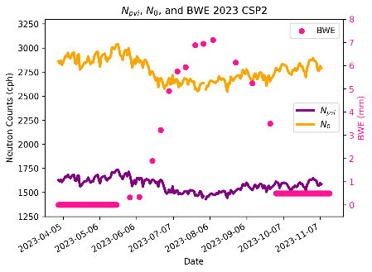

C)

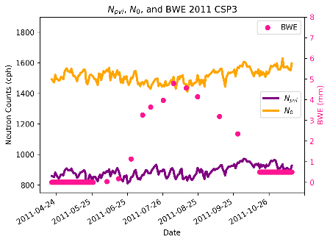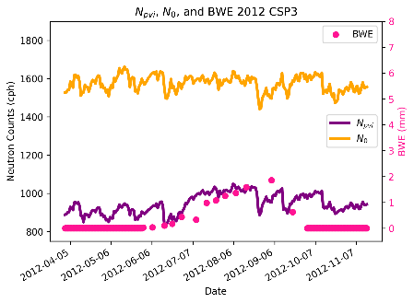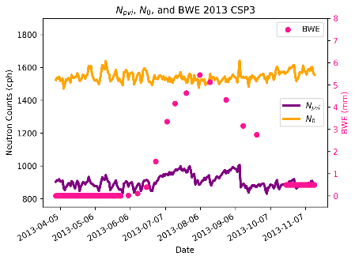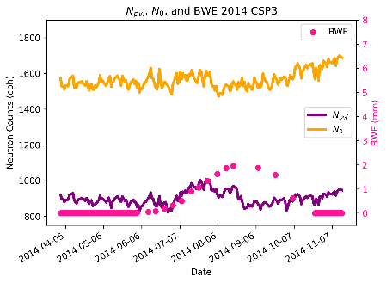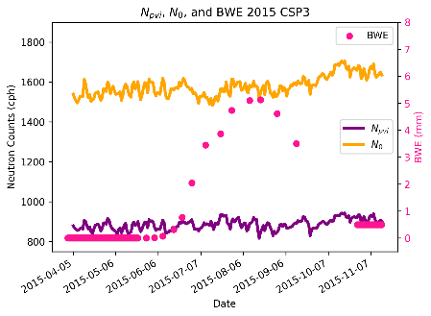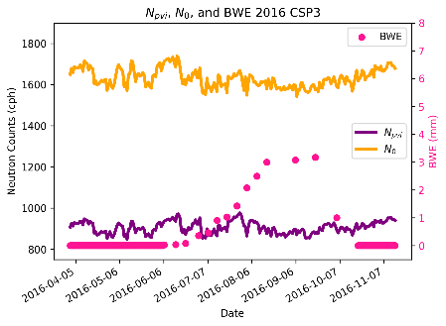

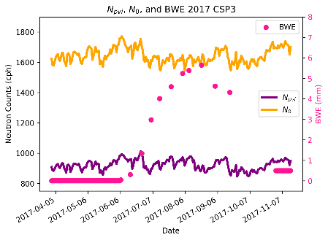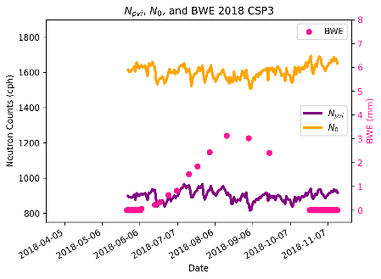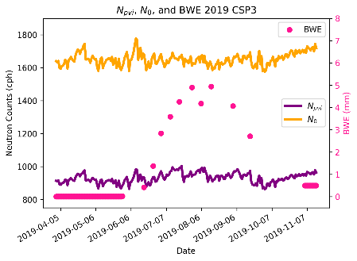

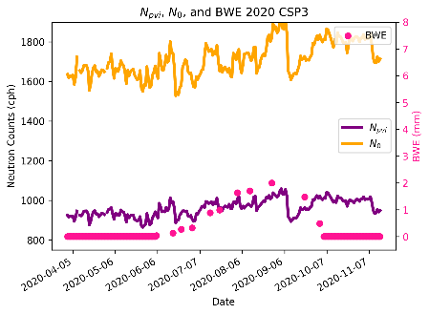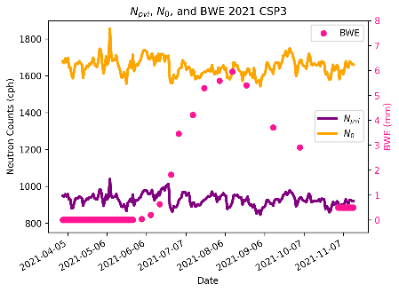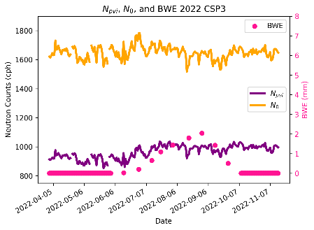

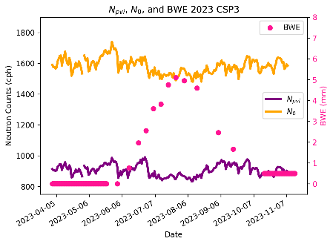

Figures S4: Plots of *Npvi, N0*, and *BWE* datetime measurements. This figure is shown to illustrate the differences between *Npvi, N0*, and their relationship to *BWE*. The purple line represents *Npvi*, the yellow line plots *N0*, and *BWE* measurements are plotted in pink. Panels A are all time series for CSP1, Panels B are all time series for CSP2, and Panels C are all time series for CSP3.

#### **Figure S5: TDR Time Series**

A)

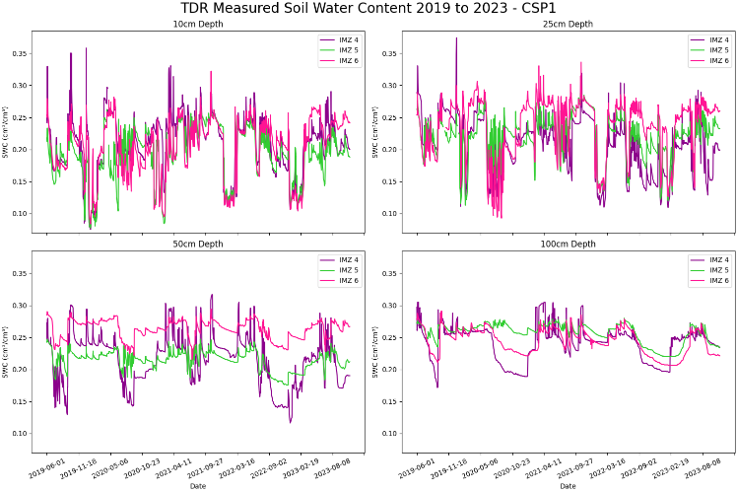

B)

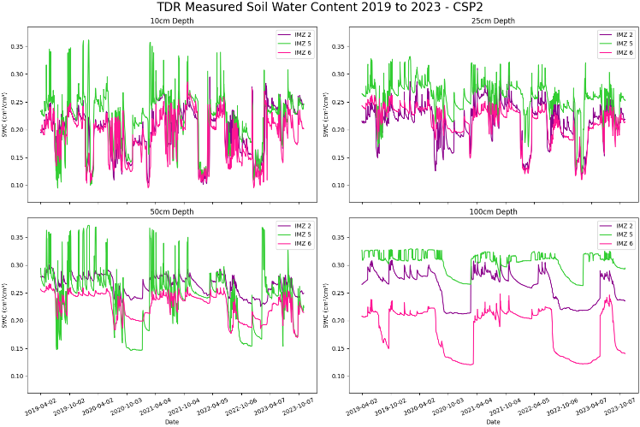

C)

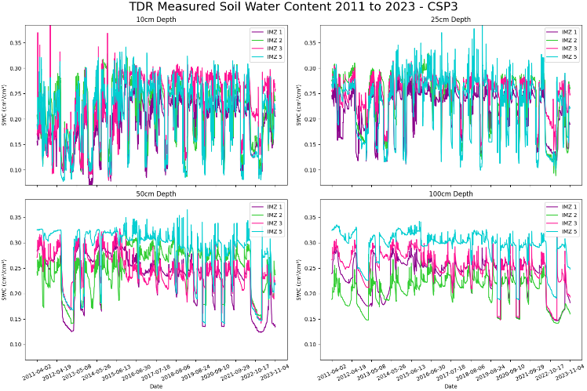

Figures S5: Plots of TDR datetime measurements. These figures show all depth in separate panels, and each IMZ as different colors. Note that only depths 10 cm and 25 cm are used in study analysis. Panel A is all time series for CSP1, Panel B is all time series for CSP2, and Panel C is all time series for CSP3.

#### **Figure S6: SWC Confidence**

A)

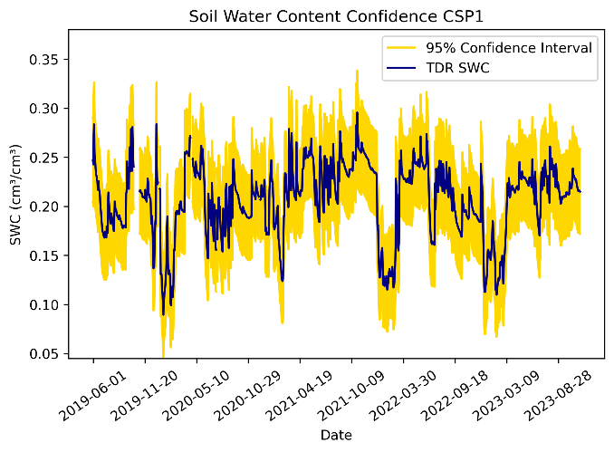

B)

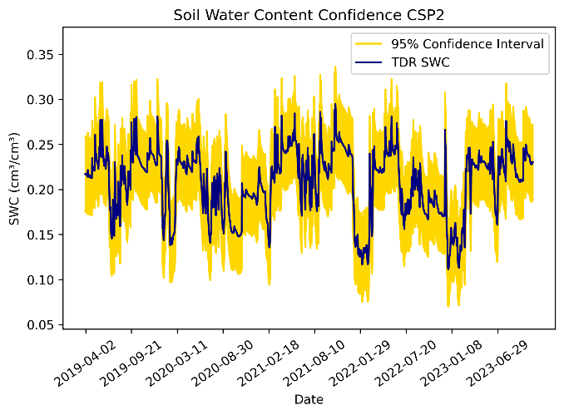

C)

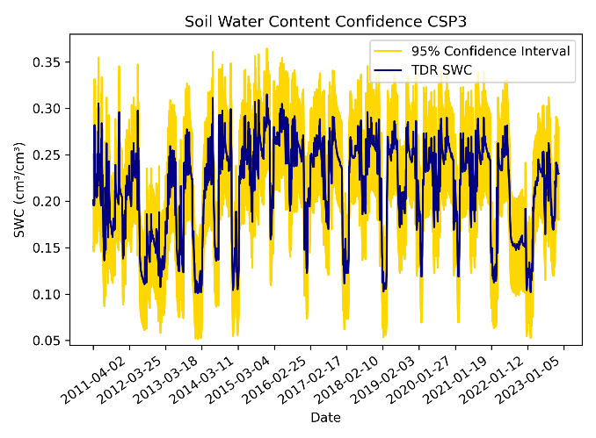

Figures S6: SWC measurement time series for all time, including winter seasons. This was calculated by using TDR measurements. The actual measurements are plotted in blue, and the 95% confidence interval is plotted in yellow.

#### **Figure S7: Precipitation, Irrigation, TDR Time Series**

A)

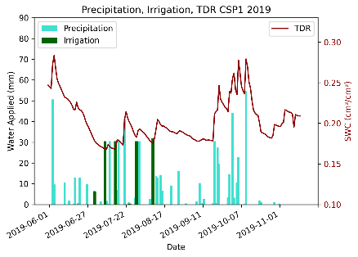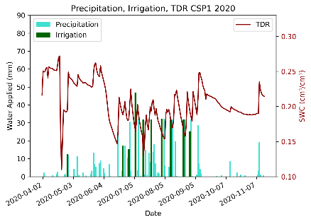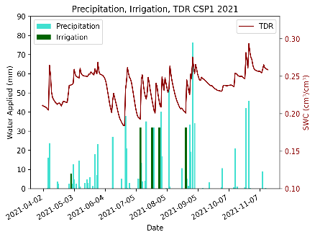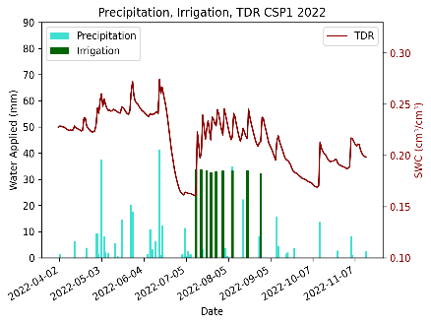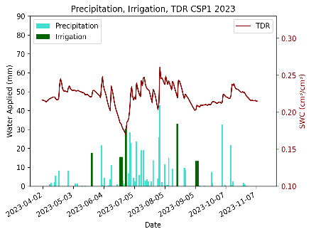

B)

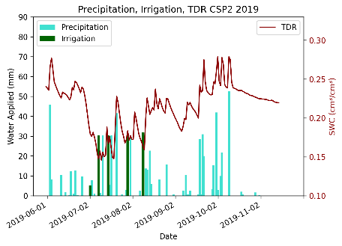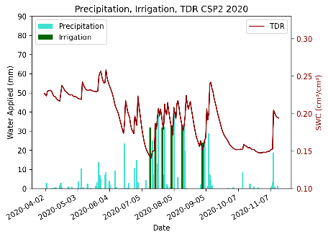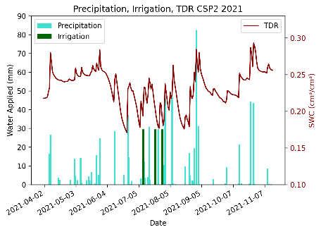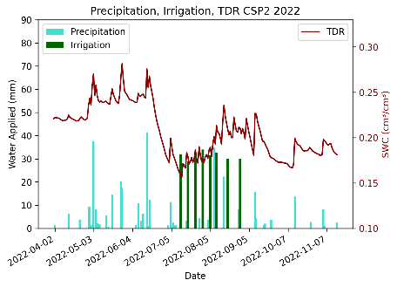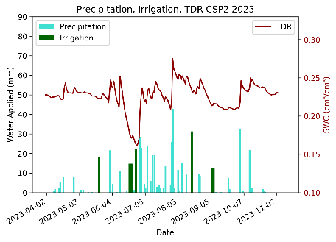

C)

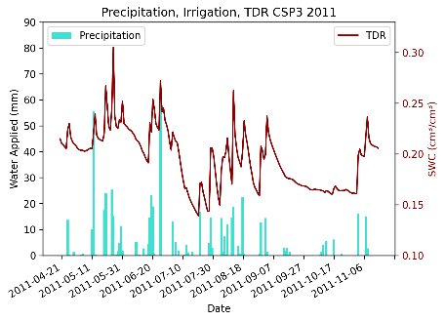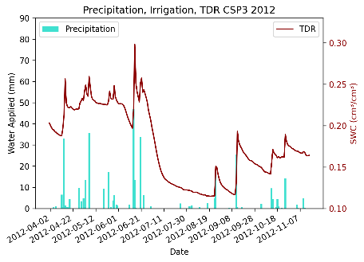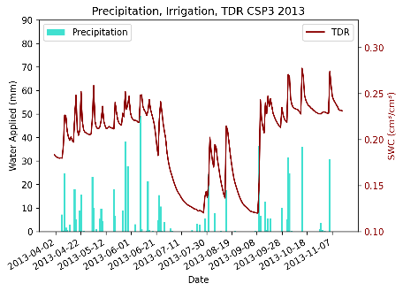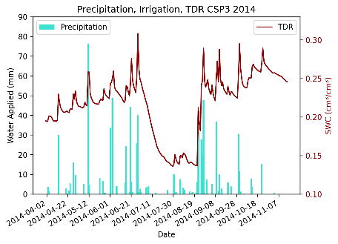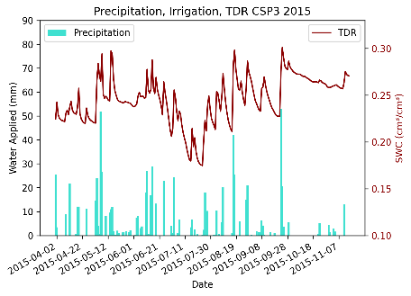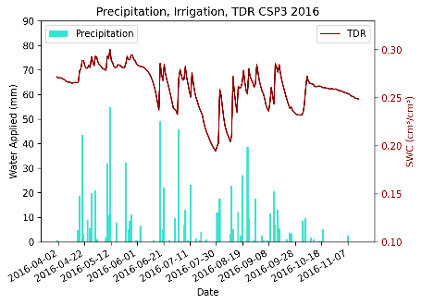

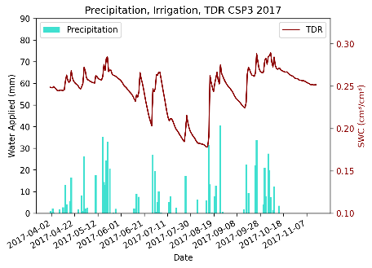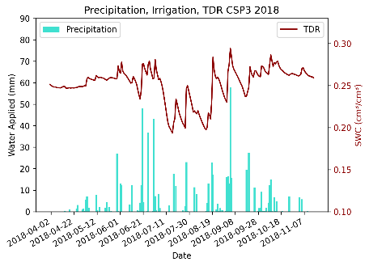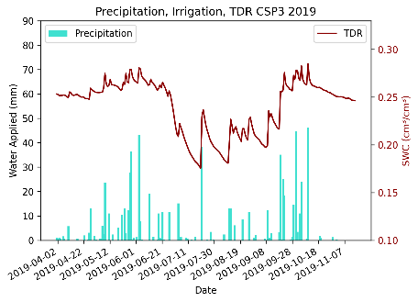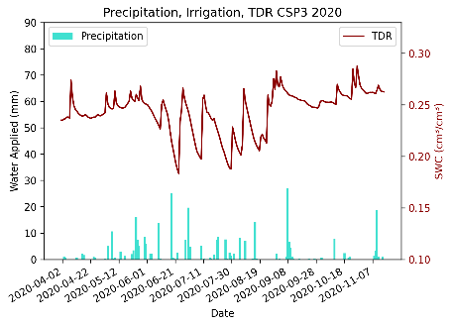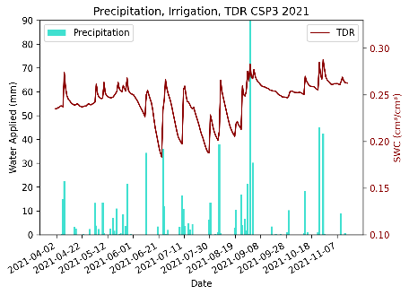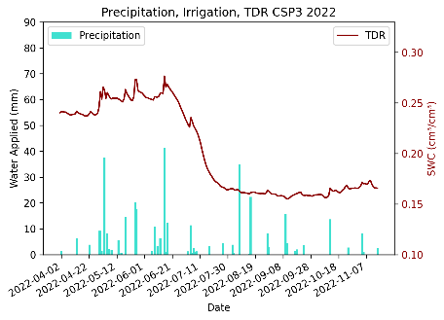

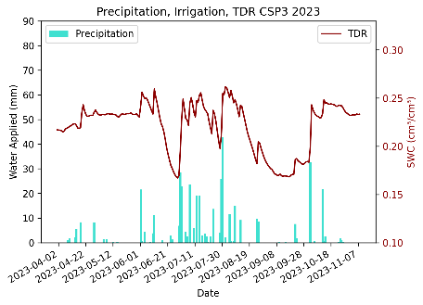

Figures S7: Plots of irrigation, precipitation, and TDR datetime measurements. Green bars represent irrigation water applied, blue bars represent precipitation, and the red line represents TDR measurements (secondary axis). Note the CSP3 field is not irrigated. Panels A are yearly time series for CSP1, Panels B are yearly time series of CSP2, and Panels C are yearly time series for CSP3.

#### **Figure S8: Gravimetric Sampling**

A)

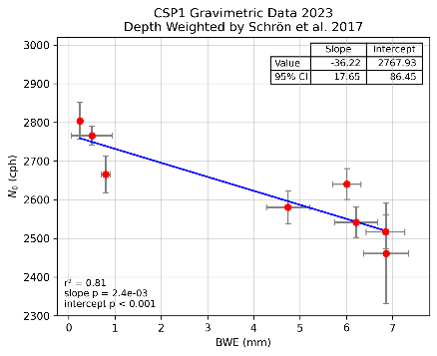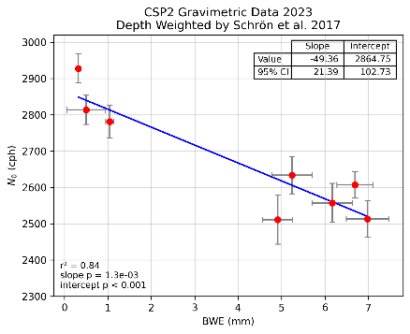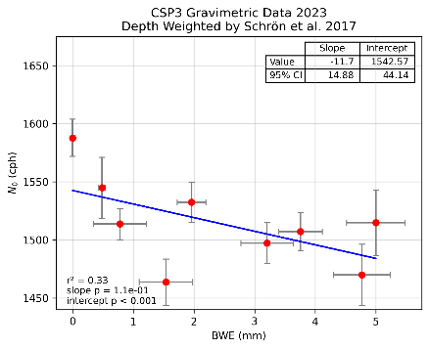

B)

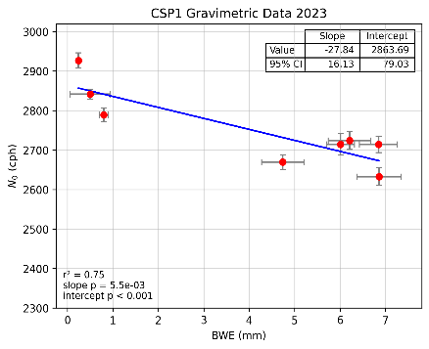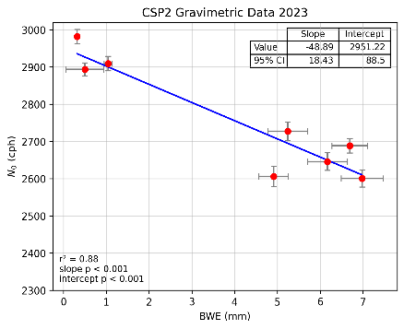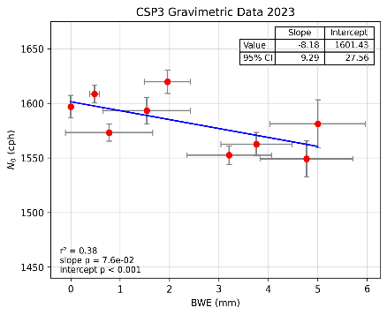

C)

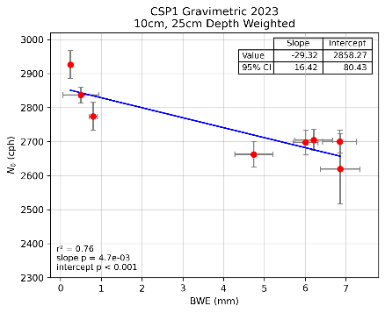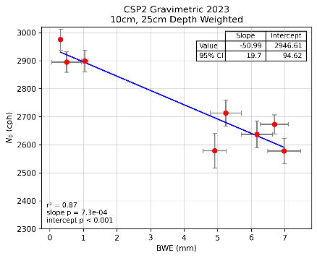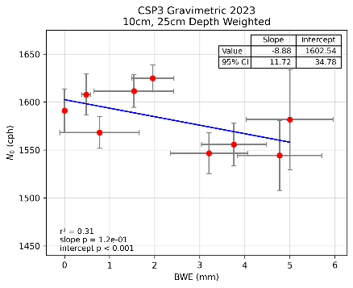

Figures B-8: Plots of *N0* vs. *BWE* resultant from 2023 gravimetric sampling. Red points represent measurements of *N0* and *BWE* with grey 95% confidence interval bars. Blue lines represent lines of best fit. Also presented are the values of slope, intercept, their 95% confidence intervals, determination of coefficients, and p-values for slope and intercept. Panels A utilize Schrön weighting, Panels B utilize arithmetic average weighting, and Panels C represent 10 cm, 25 cm depth weighting.

#### **Figure S9: N0 vs. BWE**

A)

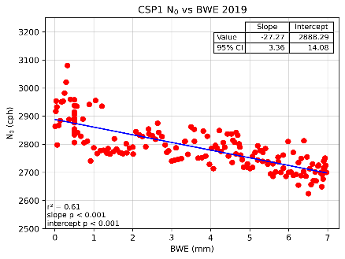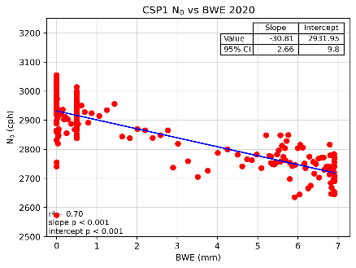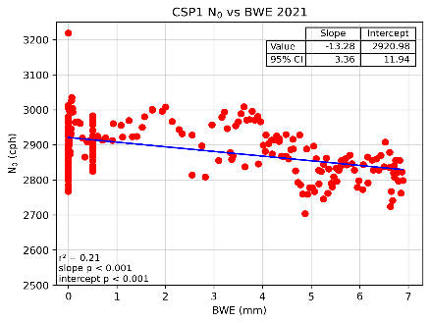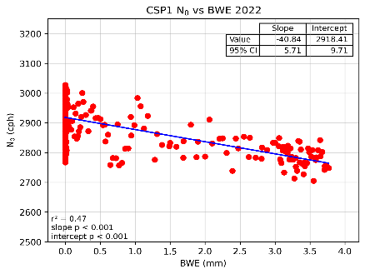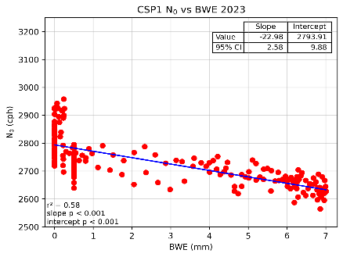

B)

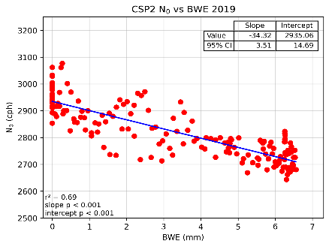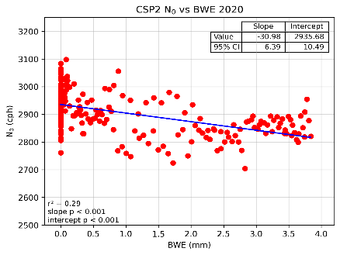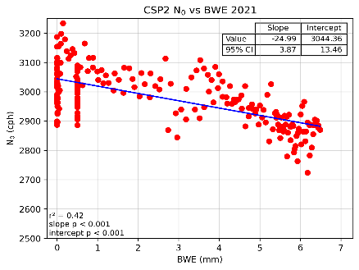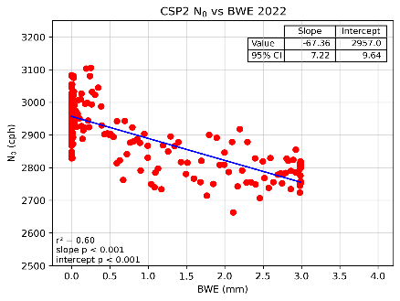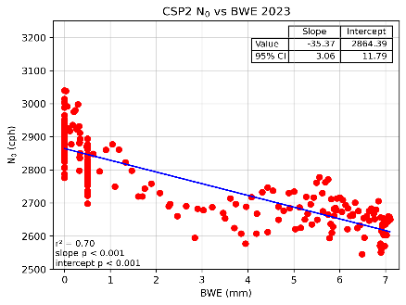

C)

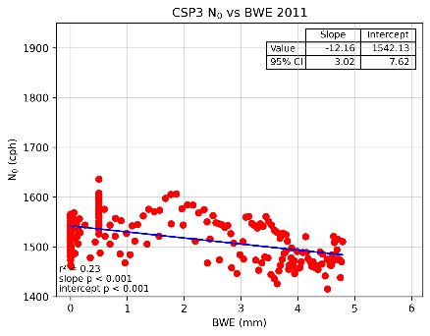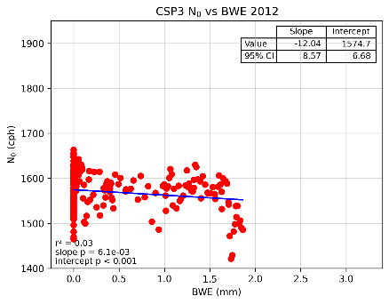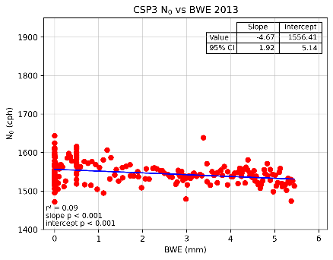

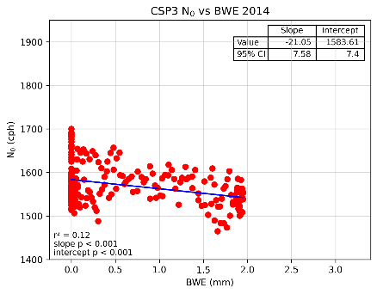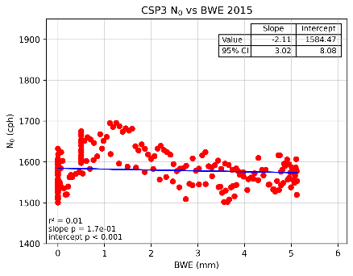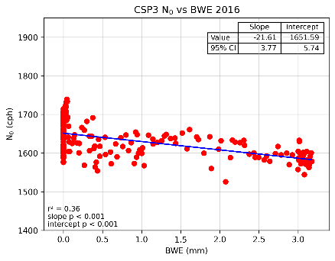

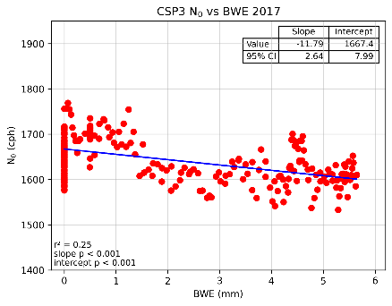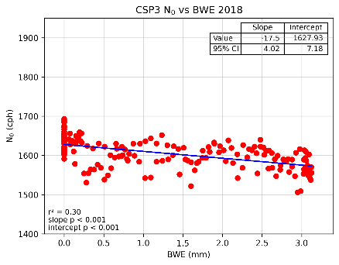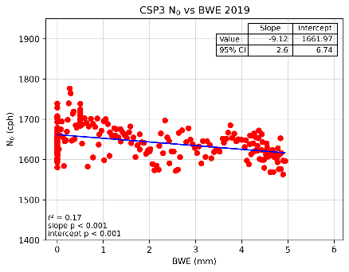

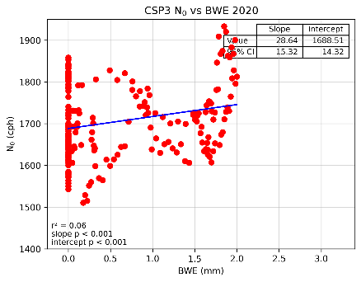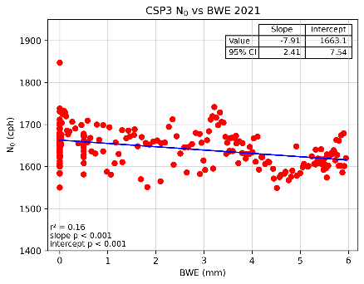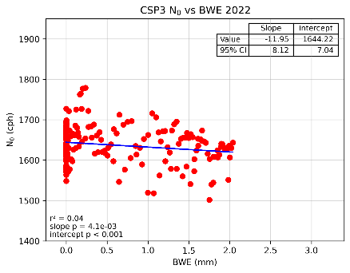

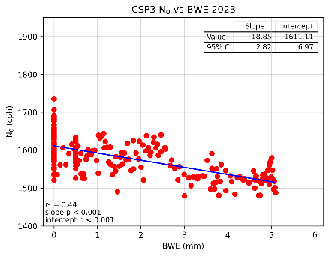

Figure S9: Yearly plots of *N0* vs *BWE* from TDR SWC measurements. Blue lines are lines of best fit. Also presented are the slope, intercept, 95% confidence intervals, r2, and p-values. Panels A, B, and C are yearly plots CSP1, CSP2, and CSP3 respectively.

#### **Figure S10: Soil Moisture Profiles**

A)

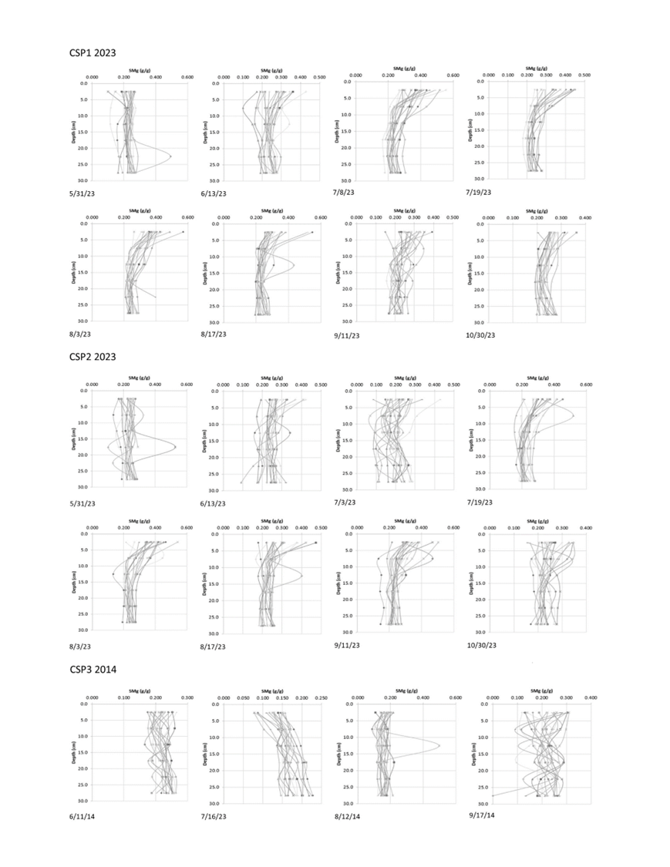

B)

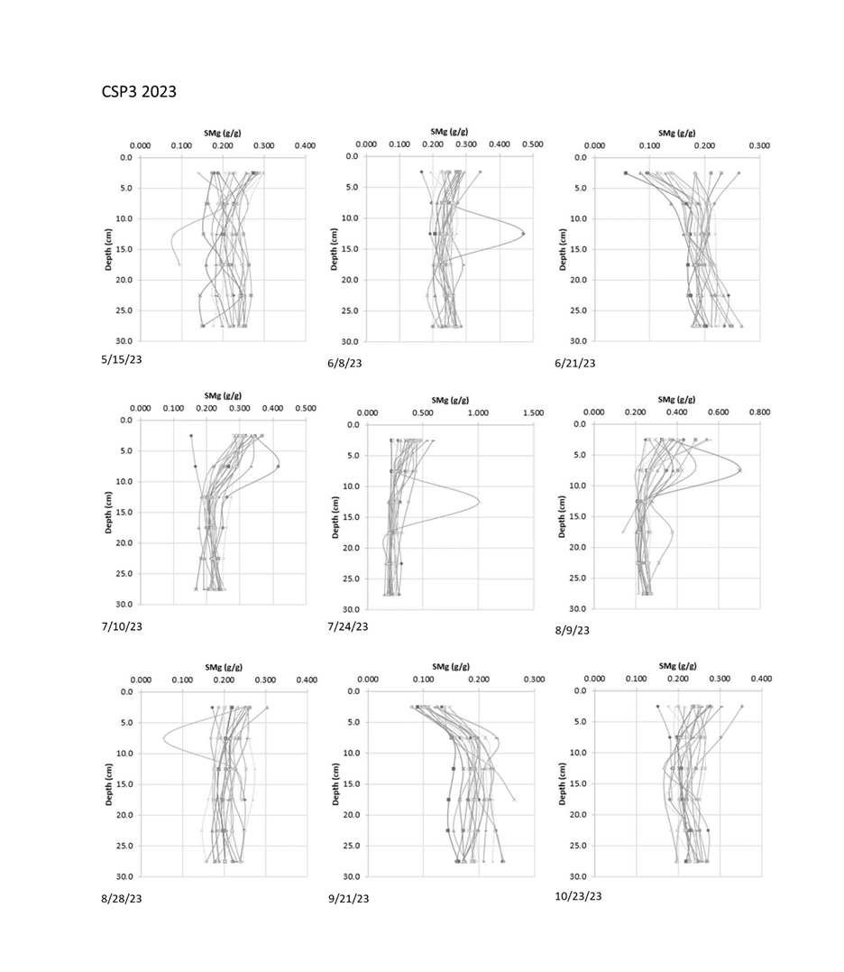

Figures S10: Soil moisture profiles for all gravimetric sampling dates for all fields. Panel A shows the profiles for CSP1 and CSP2, and Panel B shows the profiles for CSP3.

#### **Figure S11: fb**

A)

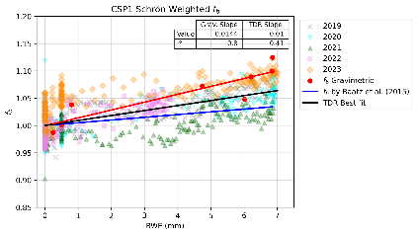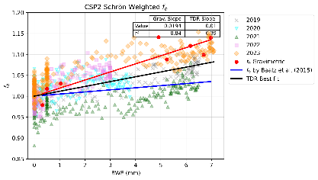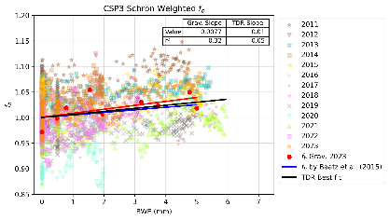

B)

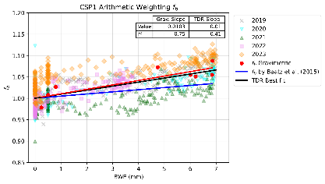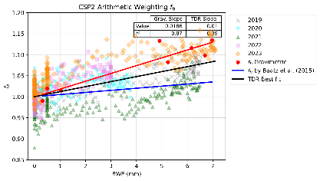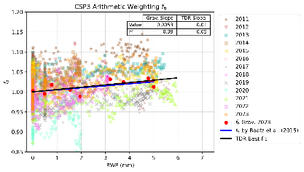

C)

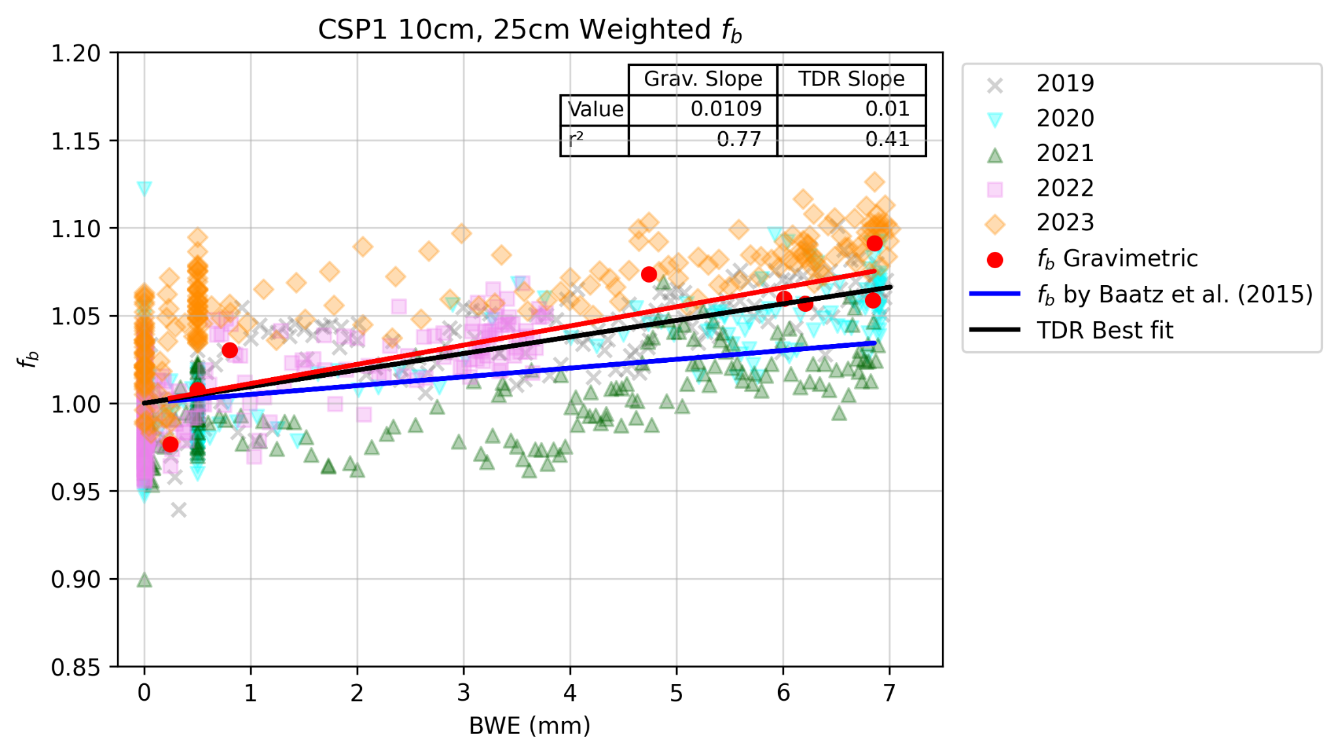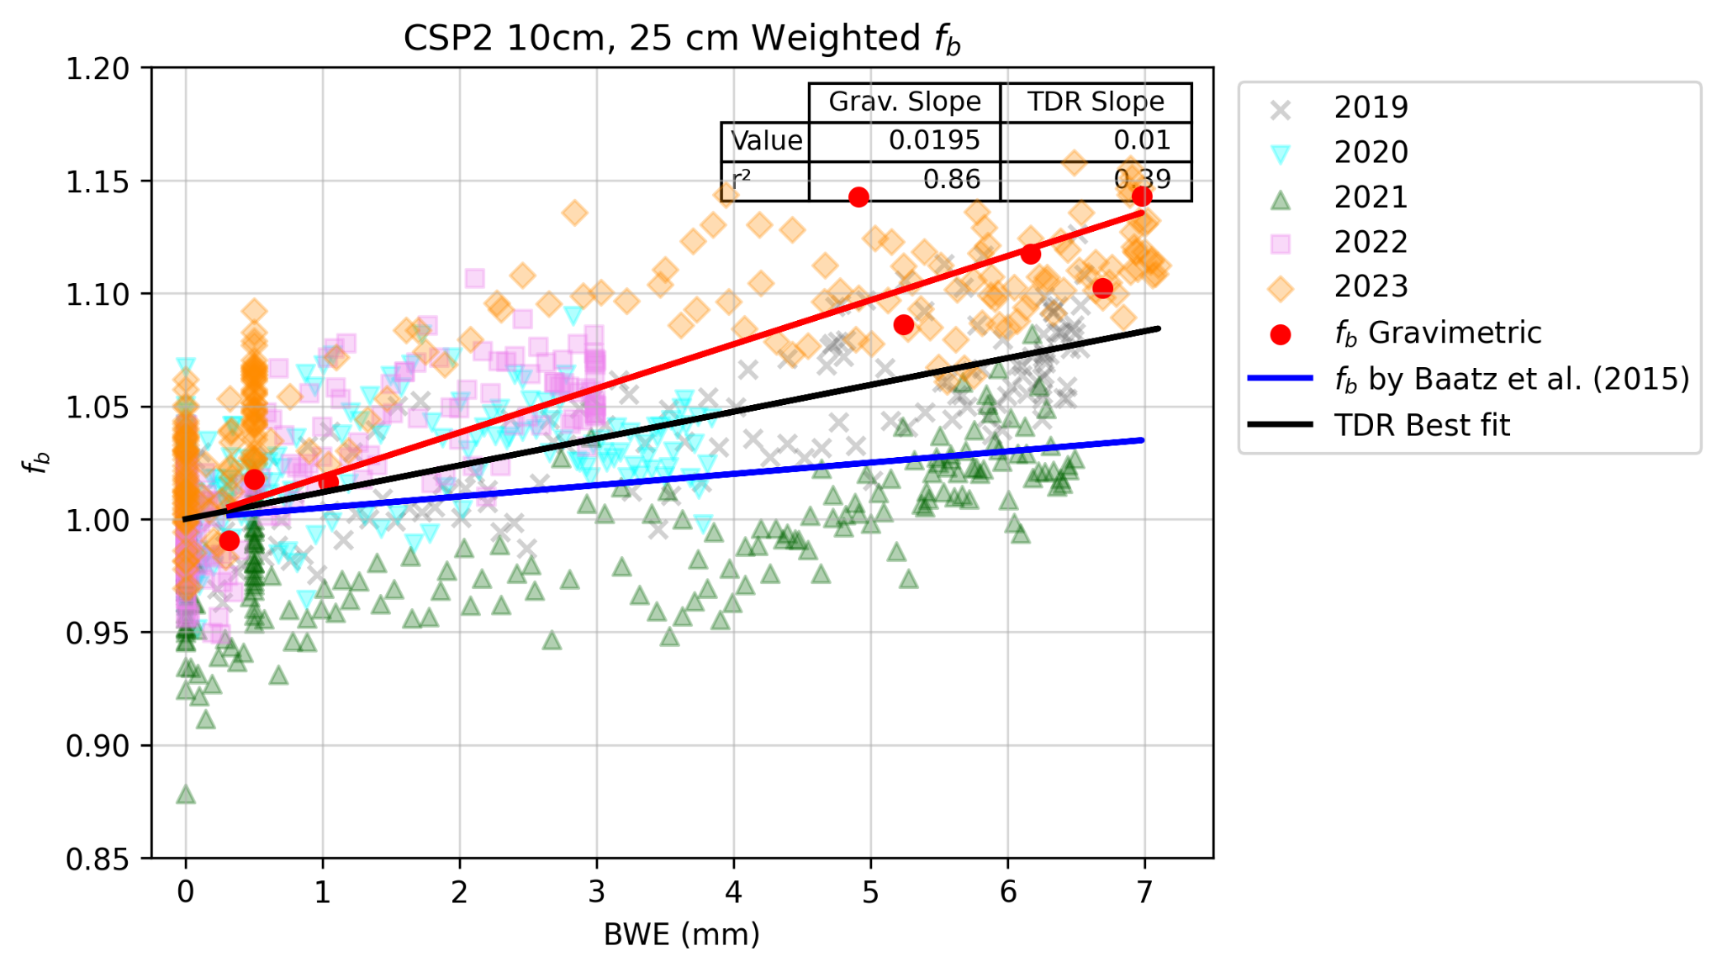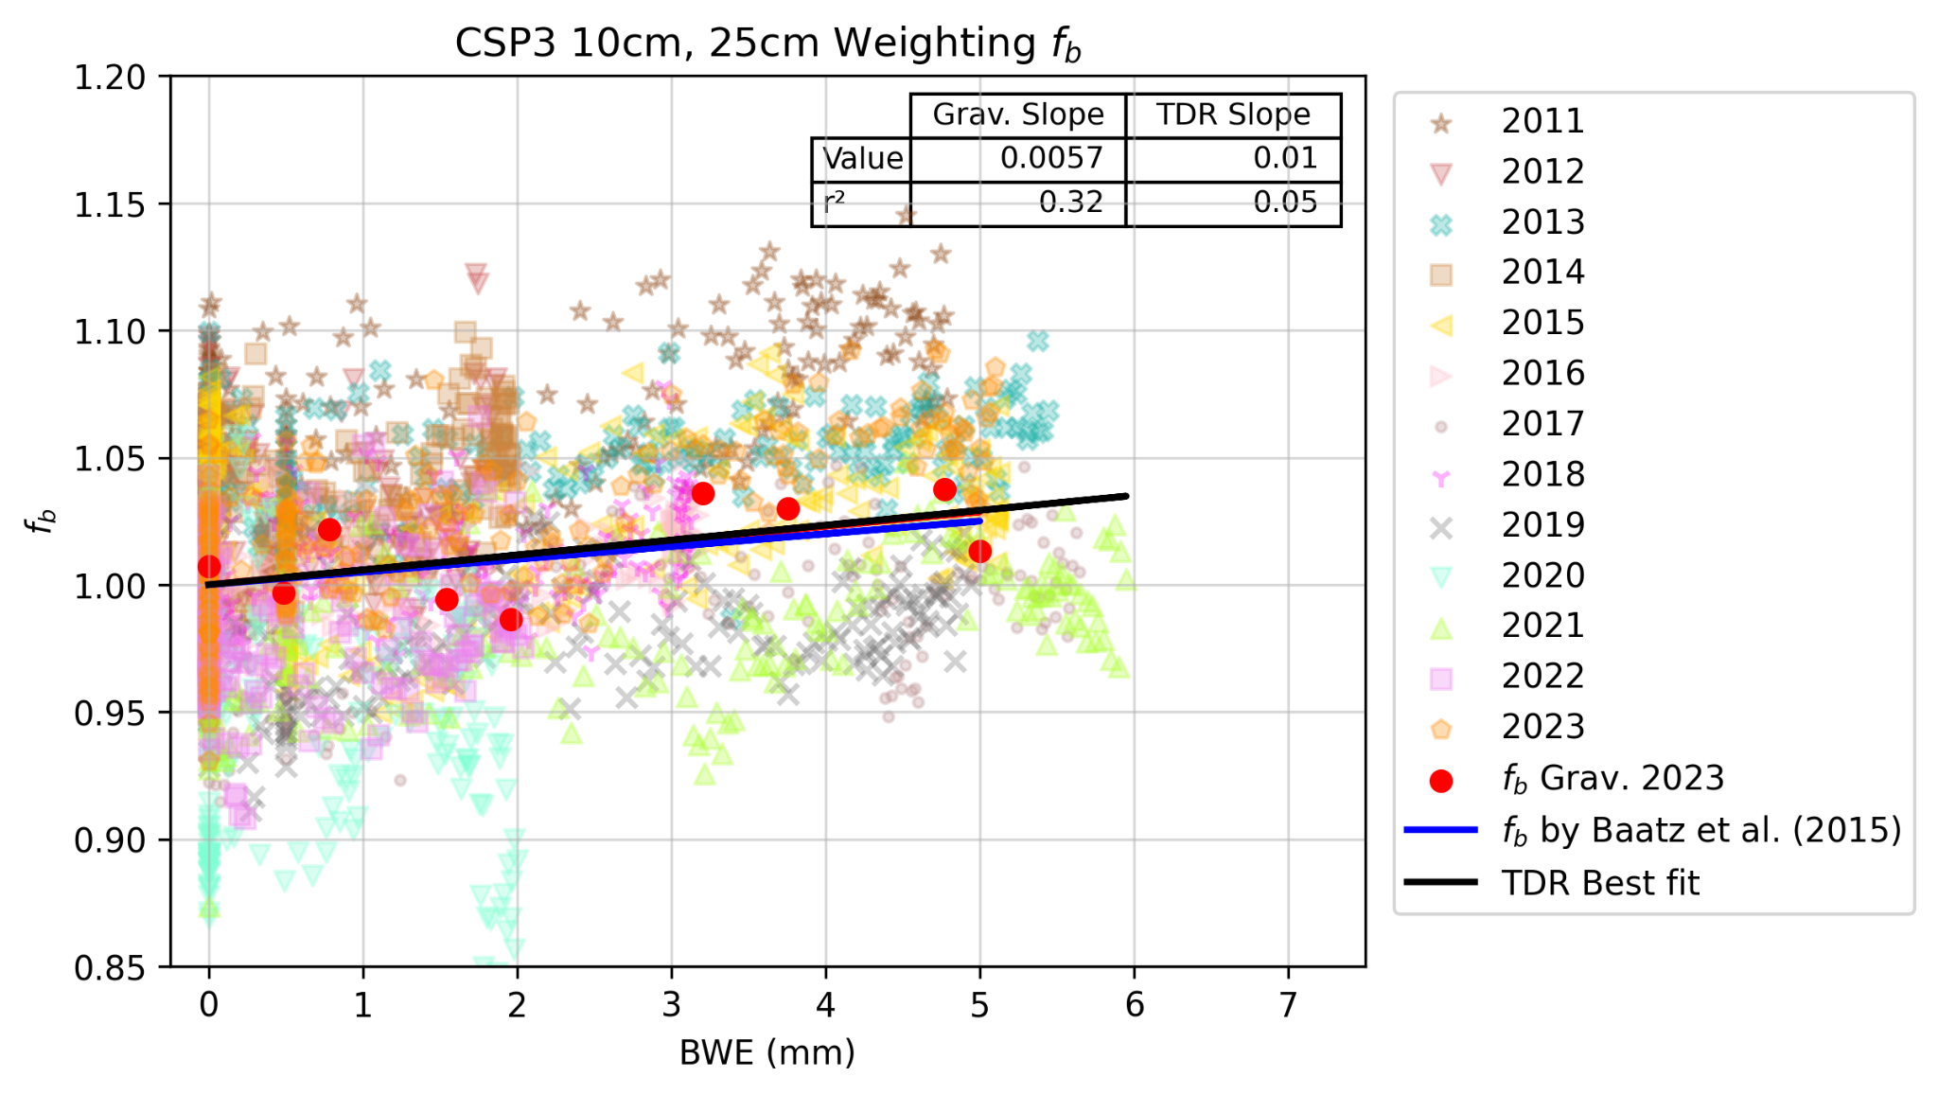

Figure S11: Plots of *fb* by gravimetric methods, TDR methods, and the Baatz et al. (2015) for reference. Lighter points represent TDR measurements and bolder points represent gravimetric measurements. The blue line is the Baatz reference line, and the black line is the TDR best fit line. Also presented are the values of gravimetric and TDR slope and their determination of coefficients. Panels A utilize Schrön weighting, Panels B utilize arithmetic average weighting, and Panels C represent 10 cm, 25 cm depth weighting.

### 

Table S1: A summary of all known studies determining biomass influence on CRNS measurements, and any proposed correction factors. This table is intended to act in conjunction with Figure 1 and Table 1. T/E is the thermal/epithermal method, *BWE* is biomass water equivalent, and AGB is aboveground biomass.

|  |  |  |  |  |  |
| --- | --- | --- | --- | --- | --- |
| Method | Summary of method | Pro | Con | fb | Source |
| T/E | Uses a moderated neutron detector (epithermal) and a bare neutron detector (thermal). The difference in ratio is used to infer changes in biomass. | Relatively easy to measure, can be used for many applications (biomass estimation) | Requires 2 CRNS sensors | Biomass presence reduces *N0* 13.8% per kg dry biomass | Vather et al., 2020 |
|  | Uses epithermal and thermal detectors. Ratio used to determine aboveground water equivalent. | Limited other corrections necessary (treat all above ground pools as AWE, rather than separate sources), creates one correction factor for all hydrogen sources on the surface, no calibration datasets needed, no area average SWC necessary | Does not explicitly correct for vegetation only | No explicit value presented. Can use linear relationship between AWE and Nr to determine *BWE*. | Tian et al., 2016 |
|  | Use epithermal/thermal ratio to determine a linear relationship correction for biomass | Same as Tian et al., 2016 | Same as Tian et al., 2016. Also requires biomass sampling for quantifying belowground biomass. | No explicit value presented. Found linear relationship between Nr and AGB, which allows quantification of dry AGB development, which can be used with belowground biomass to correct SWC estimates. | Jakobi et al., 2018 |
|  | Used neutron transport modeling and thermal to epithermal neutron ratio to determine impact of forest biomass and other forest hydrogen pools on neutron counts. | Modeled T/E neutron intensity agree with measured data, identifies specific biomass hydrogen pools, realistic forest modeling, many environments considered | Some environmental nuances overlooked, limited validation, several assumptions | Forest biomass has an influence on neutron intensity and should be corrected for. No direct value reported. | Andreasen et al., 2017 |
|  | Used mobile CRNS and T/E ratio to map soil moisture. Also compared with SMAP. Determined T/E ratio for forest vs crop environments to map land cover types. | Minimizes the need for soil sampling, more accuracy in soil moisture estimates, allows soil moisture and land cover mapping | Needs validation in more environments, requires two sensors, no direct vegetation corrections | More biomass increased thermal neutron counts (higher sensitivity) and decreased epithermal neutron counts (lower sensitivity). Lower thermal neutron intensity for agricultural fields, higher for forest. For forest this is vice versa. | Andreasen et al., 2023 |
|  | Used MCNP model to create site-specific conversions for varying land cover and CRNS to estimate soil moisture. Used T/E ratio to identify land cover type. | Allows determination of land cover type, minimizes need for soil sampling | Vegetation influence on neutron transport not well understood, site calibration still required, requires two sensors | Same as above in Andreasen et al., 2023 | Andreasen et al., 2020 |
| BWE (in-situ sampling) | Used *BWE* to account for variations in *N0* between rover observations and CRNS measurements | Accurate for individual samples and in uniformly sized plants (eg. corn and soybean are more uniform than a forest stand), a linear relationship is easy to understand and adjust for | Time and labor intensive, destructive approach, cannot measure heterogeneity of plants in area | Linear relationship can be used to correct for vegetation | Franz et al., 2015 |
| Remote Sensing | Used hyperspectral reflectance data from AVIRIS to assess the effectiveness of water content estimation methods, including NIR reflectance indices, water thickness derived from reflectance and radiance data, and SWIR water absorption bands, in estimating canopy Relative Water Content (RWC). | Non-invasive, large area analysis, easy to compare with other biomass measurements, | May not work on all plant types, depends on weather conditions and lighting, hyperspectral data difficult to acquire, difficult to validate | No direct value, but presents there may be potential in this analysis to estimate wet AGB from AVIRIS | Serrano et al., 2000 |
|  | Used NIR bands to detect water content in plant biomass | Works better than NDVI in for photosynthetic tissue sensing, narrow wavelengths of sensing make sensing certain plant matter easier, can differentiate thick tissue from thin | Only accounts for photosynthetic tissue, new index difficult to implement, depends on weather and light, difficult to validate | No direct value, but presents potential in use when canopy thickness is known | Sims & Gamon, 2002 |
|  | Used MODIS imagery to determine GrWDRVI index compared to destructive sampling | Cost effective, globally applicable in crop environments, globally available datasets, large scale monitoring available | Ground validation is difficult (same issues as *BWE* sampling), may not work in forested environments, assumes homogeneity in the MODIS cell used | No direct value reported, just that there likely is one and the value can be determined with MODIS imagery | Avery et al., 2016 |
|  | Compared COSMOS sensors to in-situ soil CRNS network and LAI measurements for validation | LAI and in-situ sensor measurements compare well to COSMOS estimates of soil moisture | Only uses LAI measurements for biomass validation, does not account for other environmental variables | Sets the idea that LAI and other vegetation indices need to be used in COSMOS validation. Could be used for dynamic vegetation cover, no explicit value. | Coopersmith et al., 2014 |
| AGB | Use above ground biomass to estimate a correction factor for plant biomass | Easily measured parameters can likely be used to estimate AGB | Values cannot be as well estimated at sites with high levels of biomass, still need AGB estimates to confirm N values, does not differentiate crop types (forest vs maize) | No direct value reported, just that there likely is one | Baatz et al., 2014 |
|  | Use above ground biomass to account for variations in *N0* | Can use *N0* to estimate AGB and vice versa. Only uses neutron counts and known correction factors to determine AGB. | Requires calibrating all sites to a reference site. | Fits a curve to the relationship of *N0* vs AGB. y=1022.53*(1/(x+1.79)+992.06. Does not explicitly correct for vegetation. | Hawdon et al., 2014 |
|  | Use wet AGB estimates, soil parameters, and hydrogen sources to determine a universal calibration function, which may be useful in estimating biomass in difficult environments | Uses publicly available forest service AGB data, can separate hydrogen sources, allows CRNS calibration in difficult environments | Assumes uniformity of variables in CRNS footprint, limited validation, biomass data not applied to real field studied biomass | No value reported, just that this method can be used for biomass estimation. | Franz et al., 2013 |
|  | Use correction factors (Baatz, 2015) AGB and traditional others to develop a general, location independent calibration function | Allows easy CRNS calibration | Still need a measurement of biomass, may lose sensor precision, need to know soil parameters, relies on uncertain biomass correction factor | Uses Baatz et al., 2015, 0.9% slope per unit AGB | Heistermann et al., 2023a (still in review) |
|  | Used ground albedo neutron sensing to test viability of this method against other soil moisture measurements. Above ground crop biomass used in the analysis. | Produces good soil moisture estimates, crops do not impact measurements greatly | High statistical variability in hourly values, unclear on larger biomass than crops, highly influenced by snow | No correction necessary for AGB in a crop environment. | Rivera Villarreyes et al., 2011 |
| Plant Allometry | Performed soil calibrations and plant matter measurements (allometric measurements) on the same days to estimate impact of vegetation on CRNS signal | Can use easily measured plant metrics to estimate vegetation content, can validate remote sensing | Requires gravimetric sampling, requires plant sampling | No direct value, but relationship is non-linear | Hornbuckle et al., 2012 |
|  | Performed measurements on plants and applied allometric equations | Doesn't require direct measurements of biomass | Requires knowing values of all hydrogen sources in the footprint, so they can be removed. Dependent on the uncertainty of soil water moisture. Should account for below-ground biomass. Need discrete plant measurements. | Follows seasonal patterns of *BWE* for both forests and maize (more rapid variation in maize, less obvious in ponderosa forest) | Franz et al., 2013 |
|  | Used forest allometry tests and root *BWE* to determine if forest seasonality and foliation had a significant effect on CRNS calibration. Also tested a new calibration function. Mixed forest environment. | Equations relatively easy to use, seasonal forest estimates not necessary, proposes a calibration function accounting for several aspects of CRNS measurement error | Requires plant measurements to perform calculations, still requires ground sampling, assumes biomass and bulk density are primary contributors to CRNS uncertainty, may be a site-specific calibration | No direct value reported. Found foliation and seasonality does not have an impact on calibration for AGB. | Heidbuchel et al., 2016 |
| Scaling Approach | Linear scaling approach used to upscale soil moisture measurements | Low cost, can be used at different time intervals (daily vs seasonal trend), easy to upscale or downscale | Requires point water measurements and extrapolate this, need N0 calibration, relies heavily on z* and vertical weighting | Fast growing biomass adds ~7mm of *BWE* | Baroni & Oswald, 2015 |
| Combination of Methods | Four correction factors for biomass were tested: in-situ biomass, generic approach, thermal to epithermal, and thermal neutron intensity were tested in 3 crops, sugar beet, winter wheat, maize | Multiple correction factors in agreement (all agree for most crops other than Nr), proves robustness of correction factors and that any could be useful | Difficult to measure *BWE*, need 2 CRNS sensors, needs validation with other soil moisture measurements, can be rigorous data analysis | Correcting vegetation influence using linear regression based on *N0* improved CRNS accuracy, Baatz linear relationship for most crops improves measurements, Nr and thermal neutron intensity improves relationship. No explicit values proposed. | Jakobi et al., 2022 |
|  | Utilized *BWE* measurements in several crops and AGB measurements in forested environment, compared against *N0*. Estimated counts with *N0* against actual counts to determine correction factor. | Simple correction factor | Still need measurements of *BWE* or AGB | 0.9% per kg/m2 of dry AGB or per 2 kg/m2 of *BWE* | Baatz et al., 2015 |
|  | Used wet AGB to quantify biomass in grasslands, forest biomass will have allometric measurements, used in the validation of the UCF. | Rules out biomass not needing a correction, new calibration useful in limited biomass | Only accounts for AGB wet biomass, shows thermal neutrons may play a role in sensor responses, and requires many measurement factors (biomass, CRNS, hmf, etc.). | There is a biomass correction needed, more work needed for high biomass environments, but equations developed for low biomass grasslands. | McJannet et al., 2014 |
|  | Long term study (4 years) dataset for use in the broader CRNS community. Used computed total biomass from weighing harvest samples (allometry functions) to determine AGB, used LAI to disentangle soil moisture signals from LAI | Extensive data availability, study covers several conditions (drought, rainfall, snow, irrigation), multi-year study captures variability in measurements | Potentially overwhelming amount of data, measurements dependent on accuracy of many instruments, limited analysis of data | No direct statement of biomass correction (need or not), primarily presents data for use in future studies | Heistermann et al., 2023b |
| Other | Use of distributed SWC measurements investigated accuracy of CRP in humid forest | Relatively easy to validate SoilNet SWC vs CRP SWCs, large network of SWC sensors available | Very difficult to measure the biomass and other organic and hydrogen influences in a humid forest, site-specific correction is not ideal | No value, just states influence of biomass on signal | Bogena et al., 2013 |

### 

Table S2: The model parameters used in the determination of significance of relationship for slope and intercept of all 3 fields.

|  |  |  |  |  |  |  |
| --- | --- | --- | --- | --- | --- | --- |
|  | Field | Year | Estimate | SE | t_value | Pr(>|t|) |
| Intercept | CSP1 | 2019 | 2888.29 | 8.27 | 349.19 | 0 |
|  | CSP1 | 2020 | 2931.95 | 5.12 | 572.9 | 0 |
|  | CSP1 | 2021 | 2920.98 | 5.5 | 530.76 | 0 |
|  | CSP1 | 2022 | 2918.41 | 4.83 | 603.77 | 0 |
|  | CSP1 | 2023 | 2680.2 | 36.37 | 73.69 | 0 |
|  | CSP2 | 2019 | 2935.06 | 8.41 | 348.99 | 0 |
|  | CSP2 | 2020 | 2935.32 | 5.25 | 559.14 | 0 |
|  | CSP2 | 2021 | 3044.36 | 6 | 507.05 | 0 |
|  | CSP2 | 2022 | 2957 | 5.17 | 572.38 | 0 |
|  | CSP2 | 2023 | 2762.19 | 39.97 | 69.11 | 0 |
|  | CSP3 | 2011 | 1542.13 | 4.51 | 342.24 | 0 |
|  | CSP3 | 2012 | 1574.7 | 3.69 | 426.67 | 0 |
|  | CSP3 | 2013 | 1556.41 | 4.11 | 378.69 | 0 |
|  | CSP3 | 2014 | 1584.11 | 3.8 | 416.84 | 0 |
|  | CSP3 | 2015 | 1584.48 | 4.18 | 378.96 | 0 |
|  | CSP3 | 2016 | 1651.59 | 3.76 | 439.19 | 0 |
|  | CSP3 | 2017 | 1667.4 | 4.27 | 390.37 | 0 |
|  | CSP3 | 2018 | 1627.93 | 5.22 | 312.13 | 0 |
|  | CSP3 | 2019 | 1661.97 | 4.28 | 388.28 | 0 |
|  | CSP3 | 2020 | 1688.51 | 3.79 | 445.82 | 0 |
|  | CSP3 | 2021 | 1663.1 | 4.32 | 384.58 | 0 |
|  | CSP3 | 2022 | 1643.99 | 3.65 | 450.13 | 0 |
|  | CSP3 | 2023 | 1493.6 | 25.12 | 59.46 | 0 |
| Slope | CSP1 | 2019 | -27.27 | 1.97 | -13.83 | 0 |
|  | CSP1 | 2020 | -30.81 | 1.39 | -22.14 | 0 |
|  | CSP1 | 2021 | -13.28 | 1.55 | -8.58 | 0 |
|  | CSP1 | 2022 | -40.84 | 2.84 | -14.36 | 0 |
|  | CSP1 | 2023 | -26.37 | 7.42 | -3.55 | 0 |
|  | CSP2 | 2019 | -34.32 | 2.01 | -17.06 | 0 |
|  | CSP2 | 2020 | -31.46 | 3.21 | -9.81 | 0 |
|  | CSP2 | 2021 | -24.99 | 1.73 | -14.47 | 0 |
|  | CSP2 | 2022 | -67.36 | 3.87 | -17.41 | 0 |
|  | CSP2 | 2023 | -45.8 | 8.32 | -5.5 | 0 |
|  | CSP3 | 2011 | -12.16 | 1.79 | -6.8 | 0 |
|  | CSP3 | 2012 | -12.04 | 4.73 | -2.54 | 0.01 |
|  | CSP3 | 2013 | -4.67 | 1.54 | -3.04 | 0 |
|  | CSP3 | 2014 | -22.66 | 3.91 | -5.79 | 0 |
|  | CSP3 | 2015 | -2.11 | 1.56 | -1.35 | 0.18 |
|  | CSP3 | 2016 | -21.61 | 2.47 | -8.74 | 0 |
|  | CSP3 | 2017 | -11.79 | 1.41 | -8.34 | 0 |
|  | CSP3 | 2018 | -17.5 | 2.92 | -5.99 | 0 |
|  | CSP3 | 2019 | -9.12 | 1.65 | -5.52 | 0 |
|  | CSP3 | 2020 | 28.64 | 4.05 | 7.07 | 0 |
|  | CSP3 | 2021 | -7.91 | 1.38 | -5.73 | 0 |
|  | CSP3 | 2022 | -11.8 | 4.22 | -2.8 | 0.01 |
|  | CSP3 | 2023 | -10.26 | 8.47 | -1.21 | 0.23 |

Table S3: A table showing the significance of relationship between slope and intercept values for each year of study in each field. Also present is a legend defining the significance of a relationship.

|  |  |  |
| --- | --- | --- |
| Legend |  |  |
| Symbol | p-value range | Significance |
| *** | 0 to 0.001 | Most |
| ** | 0.001 to 0.01 | A lot |
| * | 0.01 to 0.05 | Some |
| . | 0.05 to 0.1 | Little |
|  | >0.1 | None |

|  |  |  |  |  |  |  |  |  |
| --- | --- | --- | --- | --- | --- | --- | --- | --- |
|  | Field | Contrast | Estimate | SE | df | t_ratio | p_value | Significance |
| Intercept | CSP1 | 2019:2020 | -43.66 | 9.73 | 854 | -4.49 | 0.000 | *** |
|  | CSP1 | 2019:2021 | -32.69 | 9.93 | 854 | -3.29 | 0.009 | ** |
|  | CSP1 | 2019:2022 | -30.12 | 9.58 | 854 | -3.14 | 0.015 | * |
|  | CSP1 | 2019:2023 | 208.08 | 37.30 | 854 | 5.58 | 0.000 | *** |
|  | CSP1 | 2020:2021 | 10.97 | 7.52 | 854 | 1.46 | 0.589 |  |
|  | CSP1 | 2020:2022 | 13.54 | 7.04 | 854 | 1.92 | 0.306 |  |
|  | CSP1 | 2020:2023 | 251.75 | 36.73 | 854 | 6.85 | 0.000 | *** |
|  | CSP1 | 2021:2022 | 2.57 | 7.32 | 854 | 0.35 | 0.997 |  |
|  | CSP1 | 2021:2023 | 240.78 | 36.79 | 854 | 6.55 | 0.000 | *** |
|  | CSP1 | 2022:2023 | 238.21 | 36.69 | 854 | 6.49 | 0.000 | *** |
|  | CSP2 | 2019:2020 | -0.26 | 9.91 | 854 | -0.03 | 1.000 |  |
|  | CSP2 | 2019:2021 | -109.30 | 10.33 | 854 | -10.58 | 0.000 | *** |
|  | CSP2 | 2019:2022 | -21.94 | 9.87 | 854 | -2.22 | 0.172 |  |
|  | CSP2 | 2019:2023 | 172.87 | 40.84 | 854 | 4.23 | 0.000 | *** |
|  | CSP2 | 2020:2021 | -109.03 | 7.98 | 854 | -13.67 | 0.000 | *** |
|  | CSP2 | 2020:2022 | -21.67 | 7.37 | 854 | -2.94 | 0.028 | * |
|  | CSP2 | 2020:2023 | 173.13 | 40.31 | 854 | 4.29 | 0.000 | *** |
|  | CSP2 | 2021:2022 | 87.36 | 7.92 | 854 | 11.03 | 0.000 | *** |
|  | CSP2 | 2021:2023 | 282.17 | 40.42 | 854 | 6.98 | 0.000 | *** |
|  | CSP2 | 2022:2023 | 194.81 | 40.30 | 854 | 4.83 | 0.000 | *** |
|  | CSP3 | 2011:2012 | -32.57 | 5.82 | 2657 | -5.59 | 0.000 | *** |
|  | CSP3 | 2011:2013 | -14.28 | 6.10 | 2657 | -2.34 | 0.486 |  |
|  | CSP3 | 2011:2014 | -41.98 | 5.89 | 2657 | -7.12 | 0.000 | *** |
|  | CSP3 | 2011:2015 | -42.35 | 6.15 | 2657 | -6.89 | 0.000 | *** |
|  | CSP3 | 2011:2016 | -109.46 | 5.87 | 2657 | -18.65 | 0.000 | *** |
|  | CSP3 | 2011:2017 | -125.27 | 6.21 | 2657 | -20.18 | 0.000 | *** |
|  | CSP3 | 2011:2018 | -85.80 | 6.89 | 2657 | -12.45 | 0.000 | *** |
|  | CSP3 | 2011:2019 | -119.84 | 6.21 | 2657 | -19.28 | 0.000 | *** |
|  | CSP3 | 2011:2020 | -146.39 | 5.89 | 2657 | -24.87 | 0.000 | *** |
|  | CSP3 | 2011:2021 | -120.98 | 6.25 | 2657 | -19.37 | 0.000 | *** |
|  | CSP3 | 2011:2022 | -101.86 | 5.80 | 2657 | -17.56 | 0.000 | *** |
|  | CSP3 | 2011:2023 | 48.53 | 25.52 | 2657 | 1.90 | 0.795 |  |
|  | CSP3 | 2012:2013 | 18.29 | 5.52 | 2657 | 3.31 | 0.051 | . |
|  | CSP3 | 2012:2014 | -9.41 | 5.30 | 2657 | -1.78 | 0.861 |  |
|  | CSP3 | 2012:2015 | -9.78 | 5.58 | 2657 | -1.75 | 0.872 |  |
|  | CSP3 | 2012:2016 | -76.89 | 5.27 | 2657 | -14.59 | 0.000 | *** |
|  | CSP3 | 2012:2017 | -92.70 | 5.64 | 2657 | -16.42 | 0.000 | *** |
|  | CSP3 | 2012:2018 | -53.23 | 6.39 | 2657 | -8.33 | 0.000 | *** |
|  | CSP3 | 2012:2019 | -87.27 | 5.65 | 2657 | -15.44 | 0.000 | *** |
|  | CSP3 | 2012:2020 | -113.82 | 5.29 | 2657 | -21.52 | 0.000 | *** |
|  | CSP3 | 2012:2021 | -88.40 | 5.69 | 2657 | -15.55 | 0.000 | *** |
|  | CSP3 | 2012:2022 | -69.29 | 5.19 | 2657 | -13.35 | 0.000 | *** |
|  | CSP3 | 2012:2023 | 81.10 | 25.39 | 2657 | 3.19 | 0.072 | . |
|  | CSP3 | 2013:2014 | -27.70 | 5.60 | 2657 | -4.95 | 0.000 | *** |
|  | CSP3 | 2013:2015 | -28.07 | 5.86 | 2657 | -4.79 | 0.000 | *** |
|  | CSP3 | 2013:2016 | -95.18 | 5.57 | 2657 | -17.09 | 0.000 | *** |
|  | CSP3 | 2013:2017 | -110.99 | 5.93 | 2657 | -18.72 | 0.000 | *** |
|  | CSP3 | 2013:2018 | -71.52 | 6.64 | 2657 | -10.77 | 0.000 | *** |
|  | CSP3 | 2013:2019 | -105.56 | 5.93 | 2657 | -17.79 | 0.000 | *** |
|  | CSP3 | 2013:2020 | -132.11 | 5.59 | 2657 | -23.64 | 0.000 | *** |
|  | CSP3 | 2013:2021 | -106.69 | 5.97 | 2657 | -17.88 | 0.000 | *** |
|  | CSP3 | 2013:2022 | -87.58 | 5.50 | 2657 | -15.93 | 0.000 | *** |
|  | CSP3 | 2013:2023 | 62.81 | 25.45 | 2657 | 2.47 | 0.397 |  |
|  | CSP3 | 2014:2015 | -0.37 | 5.65 | 2657 | -0.06 | 1.000 |  |
|  | CSP3 | 2014:2016 | -67.48 | 5.35 | 2657 | -12.62 | 0.000 | *** |
|  | CSP3 | 2014:2017 | -83.29 | 5.72 | 2657 | -14.57 | 0.000 | *** |
|  | CSP3 | 2014:2018 | -43.82 | 6.45 | 2657 | -6.79 | 0.000 | *** |
|  | CSP3 | 2014:2019 | -77.86 | 5.72 | 2657 | -13.60 | 0.000 | *** |
|  | CSP3 | 2014:2020 | -104.40 | 5.37 | 2657 | -19.46 | 0.000 | *** |
|  | CSP3 | 2014:2021 | -78.99 | 5.76 | 2657 | -13.72 | 0.000 | *** |
|  | CSP3 | 2014:2022 | -59.88 | 5.27 | 2657 | -11.36 | 0.000 | *** |
|  | CSP3 | 2014:2023 | 90.51 | 25.40 | 2657 | 3.56 | 0.022 | * |
|  | CSP3 | 2015:2016 | -67.11 | 5.62 | 2657 | -11.93 | 0.000 | *** |
|  | CSP3 | 2015:2017 | -82.92 | 5.98 | 2657 | -13.87 | 0.000 | *** |
|  | CSP3 | 2015:2018 | -43.45 | 6.68 | 2657 | -6.50 | 0.000 | *** |
|  | CSP3 | 2015:2019 | -77.49 | 5.98 | 2657 | -12.95 | 0.000 | *** |
|  | CSP3 | 2015:2020 | -104.04 | 5.64 | 2657 | -18.44 | 0.000 | *** |
|  | CSP3 | 2015:2021 | -78.63 | 6.02 | 2657 | -13.07 | 0.000 | *** |
|  | CSP3 | 2015:2022 | -59.51 | 5.55 | 2657 | -10.72 | 0.000 | *** |
|  | CSP3 | 2015:2023 | 90.88 | 25.46 | 2657 | 3.57 | 0.022 | * |
|  | CSP3 | 2016:2017 | -15.81 | 5.69 | 2657 | -2.78 | 0.213 |  |
|  | CSP3 | 2016:2018 | 23.66 | 6.43 | 2657 | 3.68 | 0.015 | * |
|  | CSP3 | 2016:2019 | -10.38 | 5.70 | 2657 | -1.82 | 0.839 |  |
|  | CSP3 | 2016:2020 | -36.93 | 5.34 | 2657 | -6.92 | 0.000 | *** |
|  | CSP3 | 2016:2021 | -11.52 | 5.73 | 2657 | -2.01 | 0.727 |  |
|  | CSP3 | 2016:2022 | 7.60 | 5.24 | 2657 | 1.45 | 0.966 |  |
|  | CSP3 | 2016:2023 | 157.99 | 25.40 | 2657 | 6.22 | 0.000 | *** |
|  | CSP3 | 2017:2018 | 39.47 | 6.74 | 2657 | 5.86 | 0.000 | *** |
|  | CSP3 | 2017:2019 | 5.43 | 6.05 | 2657 | 0.90 | 1.000 |  |
|  | CSP3 | 2017:2020 | -21.11 | 5.71 | 2657 | -3.70 | 0.014 | * |
|  | CSP3 | 2017:2021 | 4.30 | 6.08 | 2657 | 0.71 | 1.000 |  |
|  | CSP3 | 2017:2022 | 23.41 | 5.62 | 2657 | 4.17 | 0.002 | ** |
|  | CSP3 | 2017:2023 | 173.80 | 25.48 | 2657 | 6.82 | 0.000 | *** |
|  | CSP3 | 2018:2019 | -34.04 | 6.75 | 2657 | -5.05 | 0.000 | *** |
|  | CSP3 | 2018:2020 | -60.59 | 6.45 | 2657 | -9.40 | 0.000 | *** |
|  | CSP3 | 2018:2021 | -35.17 | 6.78 | 2657 | -5.19 | 0.000 | *** |
|  | CSP3 | 2018:2022 | -16.06 | 6.37 | 2657 | -2.52 | 0.360 |  |
|  | CSP3 | 2018:2023 | 134.33 | 25.65 | 2657 | 5.24 | 0.000 | *** |
|  | CSP3 | 2019:2020 | -26.54 | 5.72 | 2657 | -4.64 | 0.000 | *** |
|  | CSP3 | 2019:2021 | -1.13 | 6.08 | 2657 | -0.19 | 1.000 |  |
|  | CSP3 | 2019:2022 | 17.98 | 5.63 | 2657 | 3.20 | 0.072 | . |
|  | CSP3 | 2019:2023 | 168.37 | 25.48 | 2657 | 6.61 | 0.000 | *** |
|  | CSP3 | 2020:2021 | 25.41 | 5.75 | 2657 | 4.42 | 0.001 | *** |
|  | CSP3 | 2020:2022 | 44.52 | 5.26 | 2657 | 8.46 | 0.000 | *** |
|  | CSP3 | 2020:2023 | 194.92 | 25.40 | 2657 | 7.67 | 0.000 | *** |
|  | CSP3 | 2021:2022 | 19.11 | 5.66 | 2657 | 3.38 | 0.041 | * |
|  | CSP3 | 2021:2023 | 169.51 | 25.49 | 2657 | 6.65 | 0.000 | *** |
|  | CSP3 | 2022:2023 | 150.39 | 25.38 | 2657 | 5.93 | 0.000 | *** |
| Slope | CSP1 | 2019:2020 | 3.54 | 2.41 | 854 | 1.47 | 0.584 |  |
|  | CSP1 | 2019:2021 | -13.99 | 2.51 | 854 | -5.58 | 0.000 | *** |
|  | CSP1 | 2019:2022 | 13.57 | 3.46 | 854 | 3.92 | 0.001 | *** |
|  | CSP1 | 2019:2023 | -0.90 | 7.68 | 854 | -0.12 | 1.000 |  |
|  | CSP1 | 2020:2021 | -17.53 | 2.08 | 854 | -8.42 | 0.000 | *** |
|  | CSP1 | 2020:2022 | 10.03 | 3.17 | 854 | 3.17 | 0.014 | * |
|  | CSP1 | 2020:2023 | -4.44 | 7.55 | 854 | -0.59 | 0.977 |  |
|  | CSP1 | 2021:2022 | 27.56 | 3.24 | 854 | 8.51 | 0.000 | *** |
|  | CSP1 | 2021:2023 | 13.09 | 7.58 | 854 | 1.73 | 0.419 |  |
|  | CSP1 | 2022:2023 | -14.48 | 7.95 | 854 | -1.82 | 0.362 |  |
|  | CSP2 | 2019:2020 | -2.86 | 3.79 | 854 | -0.76 | 0.943 |  |
|  | CSP2 | 2019:2021 | -9.34 | 2.65 | 854 | -3.52 | 0.004 | ** |
|  | CSP2 | 2019:2022 | 33.04 | 4.36 | 854 | 7.57 | 0.000 | *** |
|  | CSP2 | 2019:2023 | 11.48 | 8.56 | 854 | 1.34 | 0.666 |  |
|  | CSP2 | 2020:2021 | -6.48 | 3.64 | 854 | -1.78 | 0.387 |  |
|  | CSP2 | 2020:2022 | 35.90 | 5.03 | 854 | 7.14 | 0.000 | *** |
|  | CSP2 | 2020:2023 | 14.34 | 8.92 | 854 | 1.61 | 0.493 |  |
|  | CSP2 | 2021:2022 | 42.38 | 4.24 | 854 | 10.00 | 0.000 | *** |
|  | CSP2 | 2021:2023 | 20.81 | 8.50 | 854 | 2.45 | 0.104 |  |
|  | CSP2 | 2022:2023 | -21.56 | 9.18 | 854 | -2.35 | 0.131 |  |
|  | CSP3 | 2011:2012 | -0.12 | 5.06 | 2657 | -0.02 | 1.000 |  |
|  | CSP3 | 2011:2013 | -7.49 | 2.36 | 2657 | -3.18 | 0.076 | . |
|  | CSP3 | 2011:2014 | 10.50 | 4.30 | 2657 | 2.44 | 0.415 |  |
|  | CSP3 | 2011:2015 | -10.04 | 2.37 | 2657 | -4.23 | 0.002 | *** |
|  | CSP3 | 2011:2016 | 9.45 | 3.05 | 2657 | 3.10 | 0.095 | . |
|  | CSP3 | 2011:2017 | -0.37 | 2.28 | 2657 | -0.16 | 1.000 |  |
|  | CSP3 | 2011:2018 | 5.35 | 3.43 | 2657 | 1.56 | 0.942 |  |
|  | CSP3 | 2011:2019 | -3.04 | 2.43 | 2657 | -1.25 | 0.990 |  |
|  | CSP3 | 2011:2020 | -40.80 | 4.43 | 2657 | -9.21 | 0.000 | *** |
|  | CSP3 | 2011:2021 | -4.24 | 2.26 | 2657 | -1.88 | 0.808 |  |
|  | CSP3 | 2011:2022 | -0.36 | 4.58 | 2657 | -0.08 | 1.000 |  |
|  | CSP3 | 2011:2023 | -1.89 | 8.65 | 2657 | -0.22 | 1.000 |  |
|  | CSP3 | 2012:2013 | -7.37 | 4.97 | 2657 | -1.48 | 0.960 |  |
|  | CSP3 | 2012:2014 | 10.62 | 6.14 | 2657 | 1.73 | 0.883 |  |
|  | CSP3 | 2012:2015 | -9.92 | 4.98 | 2657 | -1.99 | 0.738 |  |
|  | CSP3 | 2012:2016 | 9.57 | 5.34 | 2657 | 1.79 | 0.853 |  |
|  | CSP3 | 2012:2017 | -0.25 | 4.94 | 2657 | -0.05 | 1.000 |  |
|  | CSP3 | 2012:2018 | 5.47 | 5.56 | 2657 | 0.98 | 0.999 |  |
|  | CSP3 | 2012:2019 | -2.92 | 5.01 | 2657 | -0.58 | 1.000 |  |
|  | CSP3 | 2012:2020 | -40.68 | 6.23 | 2657 | -6.53 | 0.000 | *** |
|  | CSP3 | 2012:2021 | -4.12 | 4.93 | 2657 | -0.84 | 1.000 |  |
|  | CSP3 | 2012:2022 | -0.24 | 6.34 | 2657 | -0.04 | 1.000 |  |
|  | CSP3 | 2012:2023 | -1.78 | 9.70 | 2657 | -0.18 | 1.000 |  |
|  | CSP3 | 2013:2014 | 17.99 | 4.20 | 2657 | 4.28 | 0.001 | ** |
|  | CSP3 | 2013:2015 | -2.55 | 2.19 | 2657 | -1.16 | 0.995 |  |
|  | CSP3 | 2013:2016 | 16.94 | 2.91 | 2657 | 5.82 | 0.000 | *** |
|  | CSP3 | 2013:2017 | 7.12 | 2.09 | 2657 | 3.41 | 0.037 | * |
|  | CSP3 | 2013:2018 | 12.84 | 3.30 | 2657 | 3.89 | 0.007 | ** |
|  | CSP3 | 2013:2019 | 4.45 | 2.26 | 2657 | 1.97 | 0.752 |  |
|  | CSP3 | 2013:2020 | -33.31 | 4.33 | 2657 | -7.68 | 0.000 | *** |
|  | CSP3 | 2013:2021 | 3.24 | 2.07 | 2657 | 1.57 | 0.939 |  |
|  | CSP3 | 2013:2022 | 7.13 | 4.49 | 2657 | 1.59 | 0.934 |  |
|  | CSP3 | 2013:2023 | 5.59 | 8.61 | 2657 | 0.65 | 1.000 |  |
|  | CSP3 | 2014:2015 | -20.54 | 4.21 | 2657 | -4.88 | 0.000 | *** |
|  | CSP3 | 2014:2016 | -1.05 | 4.63 | 2657 | -0.23 | 1.000 |  |
|  | CSP3 | 2014:2017 | -10.86 | 4.16 | 2657 | -2.61 | 0.303 |  |
|  | CSP3 | 2014:2018 | -5.15 | 4.88 | 2657 | -1.05 | 0.998 |  |
|  | CSP3 | 2014:2019 | -13.54 | 4.25 | 2657 | -3.19 | 0.073 | . |
|  | CSP3 | 2014:2020 | -51.29 | 5.63 | 2657 | -9.11 | 0.000 | *** |
|  | CSP3 | 2014:2021 | -14.74 | 4.15 | 2657 | -3.55 | 0.023 | * |
|  | CSP3 | 2014:2022 | -10.86 | 5.75 | 2657 | -1.89 | 0.803 |  |
|  | CSP3 | 2014:2023 | -12.39 | 9.33 | 2657 | -1.33 | 0.983 |  |
|  | CSP3 | 2015:2016 | 19.49 | 2.92 | 2657 | 6.67 | 0.000 | *** |
|  | CSP3 | 2015:2017 | 9.68 | 2.11 | 2657 | 4.59 | 0.000 | *** |
|  | CSP3 | 2015:2018 | 15.39 | 3.32 | 2657 | 4.64 | 0.000 | *** |
|  | CSP3 | 2015:2019 | 7.00 | 2.27 | 2657 | 3.08 | 0.100 | . |
|  | CSP3 | 2015:2020 | -30.75 | 4.34 | 2657 | -7.08 | 0.000 | *** |
|  | CSP3 | 2015:2021 | 5.80 | 2.08 | 2657 | 2.78 | 0.212 |  |
|  | CSP3 | 2015:2022 | 9.69 | 4.50 | 2657 | 2.15 | 0.626 |  |
|  | CSP3 | 2015:2023 | 8.15 | 8.61 | 2657 | 0.95 | 0.999 |  |
|  | CSP3 | 2016:2017 | -9.82 | 2.85 | 2657 | -3.45 | 0.033 | * |
|  | CSP3 | 2016:2018 | -4.10 | 3.83 | 2657 | -1.07 | 0.998 |  |
|  | CSP3 | 2016:2019 | -12.49 | 2.97 | 2657 | -4.20 | 0.002 | ** |
|  | CSP3 | 2016:2020 | -50.25 | 4.75 | 2657 | -10.59 | 0.000 | *** |
|  | CSP3 | 2016:2021 | -13.70 | 2.83 | 2657 | -4.84 | 0.000 | *** |
|  | CSP3 | 2016:2022 | -9.81 | 4.89 | 2657 | -2.01 | 0.729 |  |
|  | CSP3 | 2016:2023 | -11.35 | 8.82 | 2657 | -1.29 | 0.987 |  |
|  | CSP3 | 2017:2018 | 5.71 | 3.25 | 2657 | 1.76 | 0.870 |  |
|  | CSP3 | 2017:2019 | -2.67 | 2.17 | 2657 | -1.23 | 0.991 |  |
|  | CSP3 | 2017:2020 | -40.43 | 4.29 | 2657 | -9.42 | 0.000 | *** |
|  | CSP3 | 2017:2021 | -3.88 | 1.98 | 2657 | -1.96 | 0.757 |  |
|  | CSP3 | 2017:2022 | 0.01 | 4.45 | 2657 | 0.00 | 1.000 |  |
|  | CSP3 | 2017:2023 | -1.53 | 8.58 | 2657 | -0.18 | 1.000 |  |
|  | CSP3 | 2018:2019 | -8.39 | 3.36 | 2657 | -2.50 | 0.377 |  |
|  | CSP3 | 2018:2020 | -46.14 | 5.00 | 2657 | -9.23 | 0.000 | *** |
|  | CSP3 | 2018:2021 | -9.59 | 3.23 | 2657 | -2.97 | 0.135 |  |
|  | CSP3 | 2018:2022 | -5.70 | 5.13 | 2657 | -1.11 | 0.997 |  |
|  | CSP3 | 2018:2023 | -7.24 | 8.96 | 2657 | -0.81 | 1.000 |  |
|  | CSP3 | 2019:2020 | -37.76 | 4.38 | 2657 | -8.63 | 0.000 | *** |
|  | CSP3 | 2019:2021 | -1.20 | 2.15 | 2657 | -0.56 | 1.000 |  |
|  | CSP3 | 2019:2022 | 2.68 | 4.53 | 2657 | 0.59 | 1.000 |  |
|  | CSP3 | 2019:2023 | 1.15 | 8.63 | 2657 | 0.13 | 1.000 |  |
|  | CSP3 | 2020:2021 | 36.55 | 4.28 | 2657 | 8.54 | 0.000 | *** |
|  | CSP3 | 2020:2022 | 40.44 | 5.85 | 2657 | 6.91 | 0.000 | *** |
|  | CSP3 | 2020:2023 | 38.90 | 9.39 | 2657 | 4.14 | 0.002 | ** |
|  | CSP3 | 2021:2022 | 3.89 | 4.44 | 2657 | 0.88 | 1.000 |  |
|  | CSP3 | 2021:2023 | 2.35 | 8.58 | 2657 | 0.27 | 1.000 |  |
|  | CSP3 | 2022:2023 | -1.54 | 9.46 | 2657 | -0.16 | 1.000 |  |